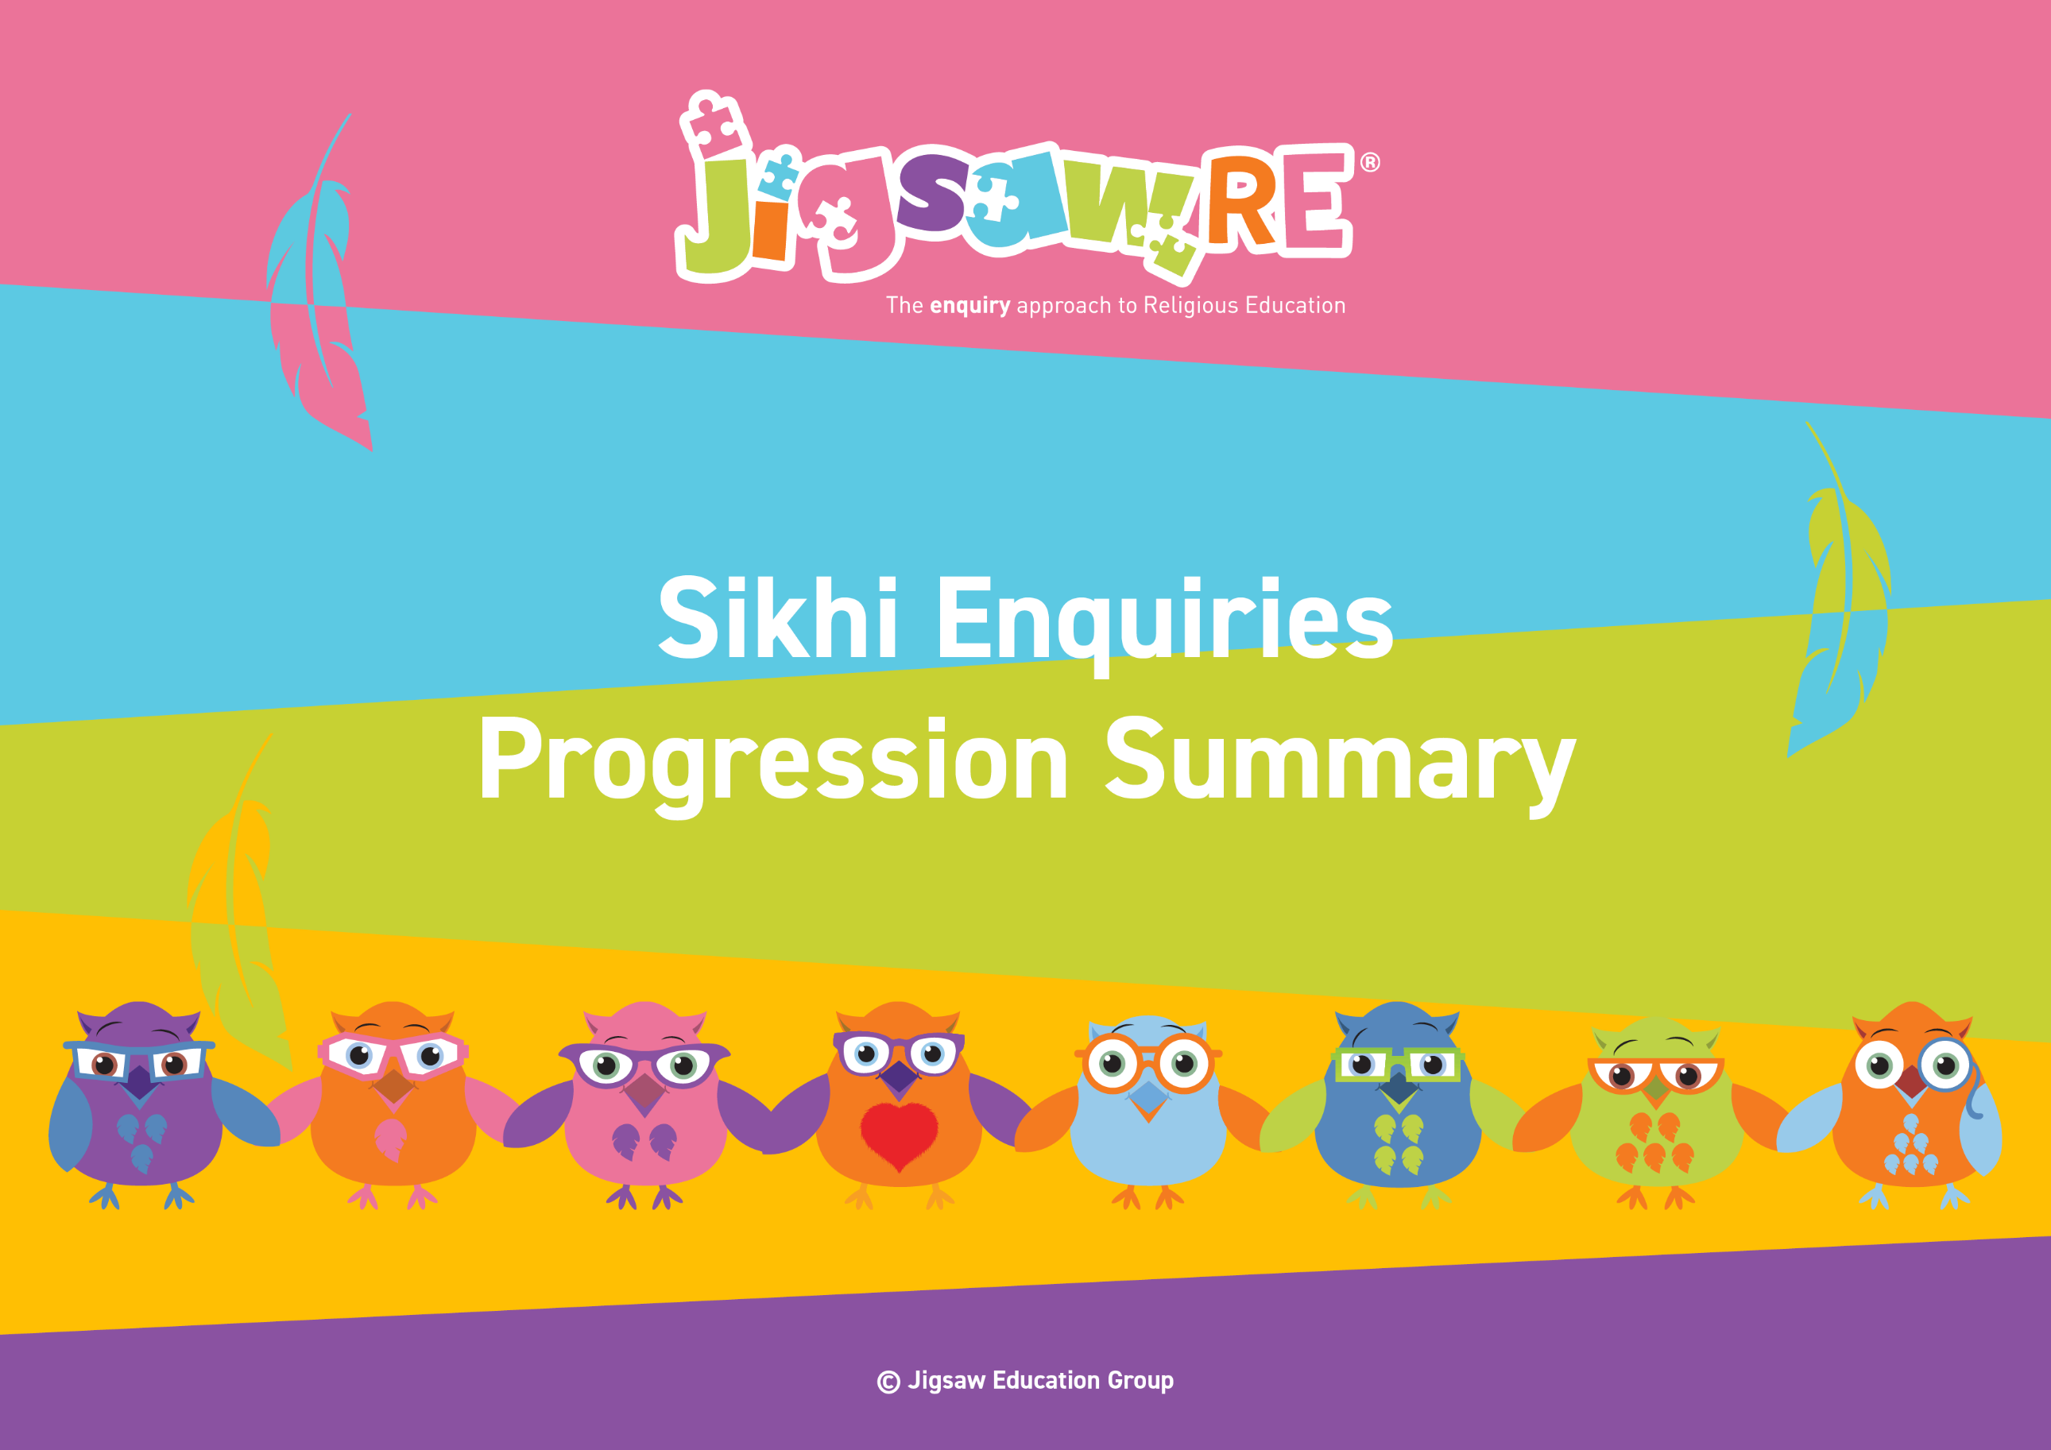







Sikhi Enquiries Progression Summary

This document collects the relevant assessment statements and key vocabulary for the Worldview in one place.
Schools can use this collated information for their own curriculum documents, such as progression maps and knowledge organisers.
This can be used alongside the knowledge organisers for each enquiry.
Schools will need to select only from which of these enquiries they have chosen to teach.


The ‘I can’ statements represent a child working at expected levels for their age groups. ‘I am starting to’ statements indicate areas where children may be showing Working Beyond. These can also be found within each individual enquiry, alongside further statements for Working Below and Working Beyond (see assessment descriptors for more detail about exact judgements for each Enquiry).

The black statements are more generic progression of skills statements within the 3 areas of learning.
These will apply to whichever enquiries and Worldviews are chosen.

Enquiry | Area of Learning:  Personal, Emotional and Social Development | Area of Learning:  Understanding the World | Area of Learning:  Communication and Language | Bridge Concept  &  Key Vocabulary
EYFS (F1)  Piece 2  Stories and me |   Develop their sense of responsibility and membership of a community.  Play with one or more children, extending and elaborating play ideas.  Talk about their feelings using words like 'happy', 'sad', 'angry' or 'worried'.  Begin to understand how others might be feeling. | I know the story of The Crocodile and The Priest  Talk about what they see using a wide vocabulary.  Continue to develop positive attitudes about the differences between people.  Know there are different countries in the world and talk about the differences they have experienced or seen in photos. | Enjoy listening to longer stories and can remember much of what happens.  Use a wider range of vocabulary.  Understand 'why' questions like: "Why do you think the caterpillar got so fat?"  Know many rhymes, be able to talk about familiar books, and be able to tell a long story.  Be able to express a point of view and to debate when they disagree with an adult or a friend, using words as well as actions. | Bridge Concept: Stories  - story  - moral  - crocodile  - Habitat  - Priest  - Sikh

EYFS (F2)  Piece 2  Stories | Build constructive and respectful relationships.  Express their feelings and consider the feelings of others.  Think about the perspectives of others. | I know the story of The Crocodile and The Priest  Compare and contrast characters from stories, including figures from the past.  Recognise that people have different beliefs and celebrate special times in different ways. |  | Understand how to listen carefully and why listening is important.  Learn new vocabulary.  Ask questions to find out more and to check they understand what has been said to them.  Describe events in some detail.  Use talk to help work out problems and organise thinking and activities explain how things work and why they might happen.  Engage in story times.  Listen to and talk about stories to build familiarity and understanding.  Retell the story once they have developed a deep familiarity with the text; some as exact repetition and some in their own words. |   Bridge Concept: Stories  - story  - moral  - crocodile  - Priest  - Sikh  - equal
Enquiry | Green Descriptors:  Personal resonance with or reflection on the concept/belief underlying the subject matter of the enquiry. The child’s own thoughts, opinions, belief, empathy.  (personal development) |  | Blue Descriptors:  Knowledge and understanding of the subject matter of that enquiry (substantive/ subject knowledge) | Red Descriptors:  Skills of evaluation, research, critical thinking in relation to the enquiry question  (disciplinary knowledge) | Bridge Concept  &  Key Vocabulary
Years 1/2  Sikhi  Generic Descriptors | I can tell you/talk about what concepts like special people/objects and respect mean to me in my world.  I can verbalise and/or express my own thoughts and feelings.  I am starting to see similarities/differences between my thoughts/feelings and other peoples’. |  | I am beginning to use the religious vocabulary from the enquiry.  I can recall knowledge about the worldview I have studied.  I am starting to explain the significance and meaning of the learning, practices etc. | I can start to think through the enquiry question using some knowledge I have learned about the Worldview.    I am beginning to see there could be more than one answer. | - Sikhs  - Guru Nanak  - Guru Granth Sahib  - Waheguru  - Gurdwara  - Seva  - Nishan Sahib
Years 1/2  Sikhi  Enquiry 1  Who is God to Sikhs? |   I can talk about what I believe in or what is important to me (Enquiry 1)  I am starting to think about things I choose to believe in and explain why they are important (Enquiry 1) |  | I know the Story of Guru Nanak (Enquiry 1)  I can re-tell a story from Sikhi and begin to explain what Sikhs believe about God (Enquiry 1) | I can say how Sikh beliefs can help them try and live a better life (Enquiry 1)  I am starting to explain some actions Sikhs might take because of their beliefs (Enquiry 1) | Bridge Concept: Special People  - special  - important  - care  - kindness  - help  - trust  - love  - happy  - safe  - teacher  - learner  - God  - equal  - share  - honest  - canopy  - rumala  - Chaur Sahib  - prayer  - generosity
Years1/2  Sikhi  Enquiry 2  Why do Sikhs admire their Gurus? | I can say some qualities that I think make a good leader (Enquiry 2) |  | I know the story of The Wise Man and the Bowl of Milk (Enquiry 2)  I know the story of Bhai Kanhaiya Ji and Guru Gobind Singh (Enquiry 2)  I can talk about the Sikh Gurus and share some of their beliefs (Enquiry 2) | I can reflect on Guru teachings and say why these teachings may still be important to Sikhs today (Enquiry 2)  I am starting to explain why the Gurus were good leaders and why they might be admired today (Enquiry 2) | Bridge Concept: Leaders  - leader  - kind  - caring  - thoughtful  - patient  - wise  - role model  - responsibilities  - communication  - Guru  - 'Ik Onkar'  - teacher  - beliefs  - Guru Tegh Bahadur  - Guru Angad  - Guru Amar Das  - Guru Ram Das  - Guru Arjan Dev  - Guru Hargobind  - Guru Har Rai  - Guru Harkrishan  - Guru Gobind Singh  - equal
Years 1/2  Sikhi  Enquiry 3  Does taking part in the Baisakhi help Sikh children feel a sense of belonging? | I can say how it feels to take part in a special celebration (Enquiry 3)  I am starting to use examples from my own life e.g. how I felt being part of a special celebration  (Enquiry 3) |  | I know the story of Vaisakhi/the story of the Khalsa (Enquiry 3)  I can remember some parts of the story of Baisakhi and say how the Khalsa was formed (Enquiry 3) | I can express an opinion about why taking part in the Baisakhi gives Sikhs a sense of belonging (Enquiry 3)  I am starting to explain why parts of the Baisakhi festival are important (Enquiry 3) | Bridge Concept: Celebration/Belonging  - celebration  - belonging  - festival  - family  - meaning  - The Khanda  - The Khalsa  - Guru Gobind Singh  - Baisakhi / Vaisakhi  - Panj Pyare  (Beloved 5)  - commitment  - sacrifice  - parade - Nagar Kirtan  - symbol  - Il Onkar  - participate  - Langar
Enquiry | Green Descriptors:  Personal resonance with or reflection on the concept/belief underlying the subject matter of the enquiry. The child’s own thoughts, opinions, belief, empathy.  (personal development) |  | Area of Learning:  Knowledge and understanding of the subject matter of that enquiry (substantive/ subject knowledge) | Area of Learning:  Skills of evaluation, research, critical thinking in relation to the enquiry question  (disciplinary knowledge) | Bridge Concept  &  Key Vocabulary
Years 3/4  Sikhi  Generic Descriptors | I can tell you/talk about the concept/belief (e.g. commitment, belonging, sharing) and start to relate this to the worldview I am studying.  I can express my own opinions and start to support them with rationales.  I can suggest similarities/differences between my thoughts/feelings and other peoples’. |  | I am using key religious vocabulary.  I can recall knowledge about the worldview I have studied.  I can select the knowledge that is most significant to the enquiry and start to explain its relevance and importance. | I can start to think through the enquiry question using some knowledge I have learned about the Worldview.  I am beginning to see there could be more than one answer. | - Sikhs  - Guru Nanak  - Guru Granth Sahib  - Waheguru  - Gurdwara  - Seva  - Nishan Sahib
Years 3/4  Sikhi  Enquiry 1  Does joining the Khalsa make someone a better Sikh? | I can discuss how, for some groups I belong to, there is an initiation ceremony, and for others there isn’t. I can talk about the difference that makes to my sense of belonging (Enquiry 1) |  | I can remember the story of the first Baisakhi or Vaisakhi/ The Birth of the Khalsa (Enquiry 3)  I can describe what might motivate a Sikh to go through the Amrit Ceremony and what happens during this (Enquiry 1)  I am starting to be able to explain how a Sikh's choice to join the Khalsa might reinforce their personal commitment to God and link this to outward symbols associated with this  (eg. 5Ks) (Enquiry 1) | I can see similarities between my experiences of joining and belonging and a Sikh’s experience of the Amrit Ceremony/Khalsa (Enquiry 1)  I am starting to talk about what I think makes someone a good person and about how joining the Khalsa might make someone feel like a ‘better’ Sikh (Enquiry 1) | Bridge Concept: Belonging  - group  - club  - belonging  - Panj Pyare  - Five beloved ones  - initiated  - Amrit Ceremony  - 5 Ks  - Kes (Kesh)  - Kanga (Kangha)  - Kashera  - Kirpan  - Kara  - Amrit Sanskar  - Baisakhi/Vaisakhi  - symbol  - promise
Years 3/4  Sikhi  Enquiry 2  Do Sikhs think it is important to share? | I can discuss why it is important to share even though it is not always easy (Enquiry 2)  I am starting to say how it feels to share and explain how this contributes to a sense of belonging (Enquiry 2) | I know the story about Guru Nanak (Enquiry 2)  I can describe some ways that Sikhs share and begin to explain why this is important to them because of their beliefs (Enquiry 2) | I can tell you if I think sharing is important or not to Sikhs and which actions I think may be more or less important (Enquiry 2) | Bridge Concept: Sharing  - share  - easy  - difficult  - generosity  - Gurus  - Guru Angad Dev Ji’  - Simran  - kind  - Karah Parshad  - Langar  - Khanda  - Harmandir Sahib  - Naam japo  - Kirat karni  - Vand ke chakna  - donating

Years 3/4  Sikhi  Enquiry 3  What is the best way for a Sikh to lead a good life? | I can explain how committing to some things can help me lead a good life (Enquiry 3)  I am starting to choose and evaluate actions I take to lead a good life and explain my reasons (Enquiry 3) | I can remember the story of Guru Nanak (Enquiry 3)  I can describe how some Sikh actions and beliefs help them live a good life (Enquiry 3)  I am starting to choose and evaluate a number of different actions a Sikh might take to lead a good life (Enquiry 3) | I can evaluate which ways may or may not help Sikhs to live a good life according to their beliefs (Enquiry 3)  I am starting to explain my reasoning about my evaluation, with respect to Sikhi (Enquiry 3) | Bridge Concept: Commitment  - promise  - commitment  - responsibility  - resilience  - 5 K's  - Khalsa  - uniform  - turban  - Langar  - Takhat  - Rumalla  - Chaur Sahib  - Golden rules  - Vand ke chanka  - Kirtan

Enquiry | Green Descriptors:  Personal resonance with or reflection on the concept/belief underlying the subject matter of the enquiry. The child’s own thoughts, opinions, belief, empathy.  (personal development) | Area of Learning:  Knowledge and understanding of the subject matter of that enquiry (substantive/ subject knowledge) | Area of Learning:  Skills of evaluation, research, critical thinking in relation to the enquiry question  (disciplinary knowledge) | Bridge Concept  &  Key Vocabulary
Years 5/6  Sikhi  Generic Descriptors | I can explain how this key concept/belief (e.g. commitment and meaning in stories) resonates in my own life and can also see this might be different for other people because of their worldview.  I can express my own thoughts and feelings clearly, having reflected on them.  I can compare my own worldview to others’. | I am using key religious vocabulary from this enquiry and previous learning.  I can recall knowledge about worldviews and explain differences in practice and interpretation within and between worldviews. | I can weigh up evidence from different sources and consider different aspects in my answer to the enquiry question.  I can discuss the diversity of different beliefs and link it to the knowledge learnt in the enquiry.  I express my answer supported by evidence and/or a rationale. | - Sikhs  - Guru Nanak  - Guru Granth Sahib  - Waheguru  - Gurdwara  - Seva  - Nishan Sahib
Years 5/6  Sikhi  Enquiry 1  How far would a Sikh go for their religion? | I can identify the different amount of effort I show to different things and explain these priorities (Enquiry 1)  I am starting to explain some of the beliefs that are important to me and how I choose to show commitment to them (Enquiry 1) | I can retell the story of the first Baisakhi or Vaisakhi/ The Birth of the Khalsa (Enquiry 3)  I know the Story of the 9th Guru - Guru Tegh Bahadur (Enquiry 3)  I can make links between how Sikhs practise their religion and the beliefs that underpin this (Enquiry 1) | I can consider some of the ways Sikhs choose to behave and the levels of commitment they show (Enquiry 1)  I am starting to express my opinion as to why Sikhs seem to show different levels of commitment and comment on this (Enquiry 1) | Bridge Concept: Standing up for what you believe in  - belief  - commitment  - ideal/ideology  - loyalty  - support  - Khalsa  - Baisakhi or Vaisakhi  - 3 Pillars  - Amrit Dhari  - Guru Tegh Bahadur Ji  - courage  - integrity  - oppression  - injustice  - selflessness  - self-sacrifice  - Vand ke Chakna  - equality  - pilgrimage  - Harmandir Sahib  - compassion  - generosity  - pledge
Years 5/6  Sikhi  Enquiry 2  How are sacred teachings and stories interpreted by Sikhs today? | I can explain how some stories can teach people about what is important and how to behave (Enquiry 2)  I am starting to give my opinion as to why stories may be important to people today (Enquiry 2) | I know The Story of Bhai Kanaya, The Story of Bhai Lallo Ji and Malik Bhago and The Story of Bibi Bhani (Enquiry 3)  I know the key events in the life of Guru Amar Das (Enquiry 3)  I can recognise that stories can be an important way of expressing belief and meaning and can explain the relevance of a Sikh story (Enquiry 2) | I can explain how some stories can teach Sikhs about what is important in life and relate this to non-Sikhs (Enquiry 2)  I am starting to explain why Sikh stories could be considered important today (Enquiry 2) | Bridge Concept: Meaning in Stories  - stories  - meanings  - moral  - teacher  - Guru Gobind Singh  - Bhai Kanaya  - care  - compassion  - share  - kindness  - equality  - Chapati  - Malik Bhago  - Parable  - morals  - values  - Guru Amar Das  - Gender equality  - Equal rights  - Women’s rights  - Bhai Kayana  - Malik Bhago  - Guru Amar Das Ji  - concept  - theme
Years 5/6  Sikhi  Enquiry 3  What is the best way for a Sikh to show commitment to God? | I can express why showing commitment to something may be a good thing (Enquiry 3)  I can show an understanding of why people show commitment in different ways (Enquiry 3)  I am starting to explain why one way of showing commitment may not be better than another  (Enquiry 3) | I can describe how different practices enable Sikhs to show their commitment to God and understand that some of these will be more significant to some Sikhs than others (Enquiry 3)  I am starting to explain why it is important to Sikhs to show their commitment to God (Enquiry 3) | I can express what I think about the best way a Sikh could show commitment to God (Enquiry 3)  I am starting to give my opinion on what I think Sikhs should do to show commitment to God and explain why (Enquiry 3) | Bridge Concept: Commitment  - choice  - debate  - commitment  - Turban  - Kara  - initiated  - Naam japna  - Vand Ke Chakna  - Kirat Karnee  - Langar  - Guru Amar Das / Guru Amardas Ji (3rd Guru)  - Guru Har Gobind Sahib (6th Guru)  - equality  - Gender equality  - Equal rights  - Women’s rights  - Akal Takhat  - Harmandir Sahib  - Maharaja Ranjit Singh  - worship  - congregation

