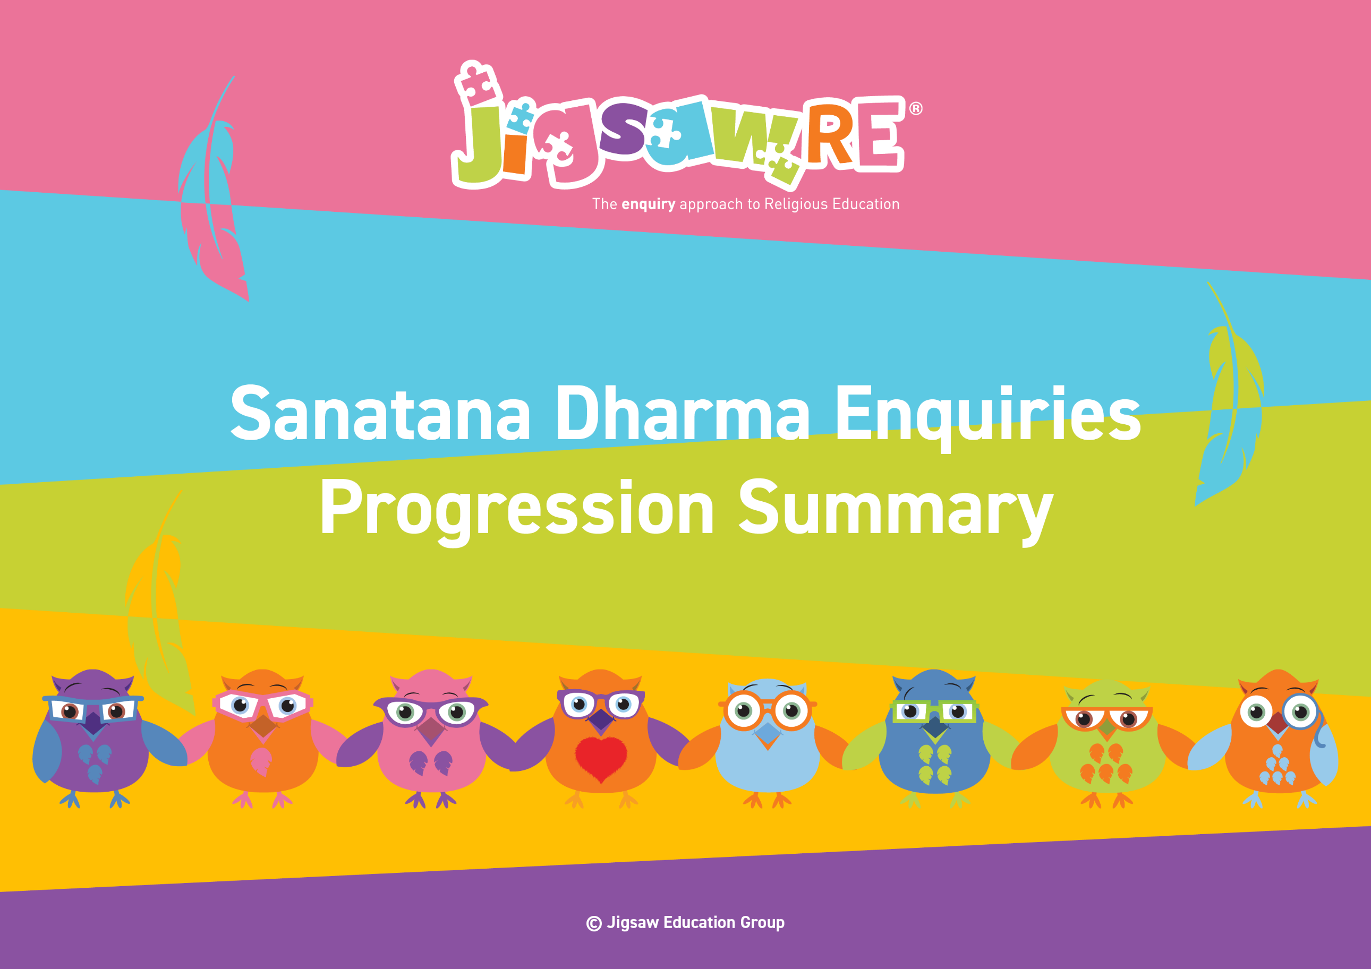







Sanatana Dharma Enquiries Progression Summary

This document collects the relevant assessment statements and key vocabulary for the Worldview in one place.
Schools can use this collated information for their own curriculum documents, such as progression maps and knowledge organisers.
This can be used alongside the knowledge organisers for each enquiry.
Schools will need to select only from which of these enquiries they have chosen to teach.


The ‘I can’ statements represent a child working at expected levels for their age groups. ‘I am starting to’ statements indicate areas where children may be showing Working Beyond. These can also be found within each individual enquiry, alongside further statements for Working Below and Working Beyond (see assessment descriptors for more detail about exact judgements for each Enquiry).

The black statements are more generic progression of skills statements within the 3 areas of learning.
These will apply to whichever enquiries and Worldviews are chosen.

Enquiry | Area of Learning:  Personal, Emotional and Social Development | Area of Learning:  Understanding the World |  | Area of Learning:  Communication and Language | Bridge Concept  &  Key Vocabulary
  EYFS (F1)  Piece 6 | Play with one or more children, extending and elaborating play ideas.  Talk about their feelings using words like 'happy', 'sad', 'angry' or 'worried'.  Begin to understand how others might be feeling. | Talk about what they see using a wide vocabulary.  Continue to develop positive attitudes about the differences between people.  Know there are different countries in the world and talk about the differences they have experienced or seen in photos. |  | Enjoy listening to longer stories and can remember much of what happens.  Use a wider range of vocabulary.  Sing a large repertoire of songs.    Know many rhymes, be able to talk about familiar books, and be able to tell a long story. | Bridge Concept: Celebrations  - Faith  - Religion  - Belief  - Sanatana Dharma  - Sanatani  - Holi
EYFS (F2)  Piece 6 | Build constructive and respectful relationships.  Express their feelings and consider the feelings of others.  Identify and moderate their own feelings socially and emotionally.  Think about the perspectives of others. | Recognise that people have different beliefs and celebrate special times in different ways.  Recognise some similarities and differences between life in this country and life in other countries.  Understand the effect of changing seasons on the natural world around them. |  | Understand how to listen carefully and why listening is important.  Learn new vocabulary.  Ask questions to find out more and to check they understand what has been said to them.  Describe events in some detail.  Use talk to help work out problems and organise thinking and activities explain how things work and why they might happen.  Engage in story times.  Listen to and talk about stories to build familiarity and understanding.  Retell the story once they have developed a deep familiarity with the text; some as exact repetition and some in their own words. | Bridge Concept: Celebrations  - Celebration  - Sanatana Dharma  - India  - Holi  - Spring  - Good  - Evil  - Triumph
    Enquiry | Green Descriptors:  Personal resonance with or reflection on the concept/belief underlying the subject matter of the enquiry. The child’s own thoughts, opinions, belief, empathy.  (personal development) |  | Blue Descriptors:  Knowledge and understanding of the subject matter of that enquiry (substantive/ subject knowledge) | Red Descriptors:  Skills of evaluation, research, critical thinking in relation to the enquiry question  (disciplinary knowledge) | Bridge Concept  &  Key Vocabulary
Years 1/2  Sanatana Dharma  Generic Descriptors | I can tell you/talk about what concepts like symbols and belonging mean to me in my world.  I can verbalise and/or express my own thoughts and feelings.  I am starting to see similarities/differences between my thoughts/feelings and other peoples’. |  | I am starting to use the religious vocabulary from the enquiry.  I can recall knowledge about the worldview I have studied.  I am starting to explain the significance and meaning of the learning, practices etc. | I can start to think through the enquiry question using some knowledge I have learned about the Worldview.  I am starting to see there could be more than one answer. | - Atman  - Brahman  - Sanatana Dharma  - Sanatani  - Brahma  - Deity  - God  - Supreme
Years 1/2  Sanatana Dharma  Enquiry 1  Who is God to Sanatanis? | I can talk about different parts of my personality (Enquiry 1)  I can say some of the different roles I take in life (Enquiry 1) |  | I know the stories of Ganesha and Lakshmi (Enquiry 1)  I can remember some Sanatani beliefs about Brahman (Enquiry 1)  I am starting to explain the different roles Brahman might have (Enquiry 1) | I can say how a Sanatani's beliefs might impact their life (Enquiry 1)  I am starting to explain the actions a Sanatani might or might not take because of their beliefs (Enquiry 1) | Bridge Concept: Different aspects of me  - Aspect  - Character  - Face  - Personality  - Role  - Character  - Face  - Personality  - Role  - Creator  - Destroyer  - Preserver  - Shiva  - Ganesha  - Lakshmi  - Puja  - Vishnu  - Respect
Years 1/2  Sanatana Dharma Enquiry 2  What might Sanatanis learn from the story of Rama and Sita and the celebrations of Diwali? | I can tell you why belonging is important to me (Enquiry 2) |  | I know the story of Rama and Sita (Enquiry 2)  I can describe some of the ways a Sanatani might celebrate Diwali and how these celebrations relate to the story of Rama and Sita (Enquiry 2) | I can say how Diwali helps a Sanatani child feel like they belong (Enquiry 2)  I can explain why the story of Rama and Sita might be important to Sanatanis today (Enquiry 2) | Bridge Concept: Belonging  - Belonging  - Commitment  - Promise  - Gratitude  - Included  - Excluded  - Welcoming  - Diwali  - Festival  - King Ravana  - Hanuman  - Lakshmana  - Ramayana  - Rama  - Sita  - Light  - Dark  - Good  - Evil  - Right  - Wrong  - Rangoli  - Mendhi patterns  - Diva lamps  - Prayer  - Puja
Years 1/2  Sanatana Dharma Enquiry 3  Why do Sanatanis use symbols? | I can say why a symbol might be meaningful to me  (Enquiry 3)  I am starting to say how I would use a symbol to remind me of important things (Enquiry 3) |  | I know the Creation Story (Enquiry 3)  I can remember some Sanatani symbols and explain what they might mean (Enquiry 3)  I am starting to say why Sanatani symbols are meaningful today (Enquiry 3) | I can say how symbols might impact the life of a Sanatani (Enquiry 3)  I am starting to explain why I think Sanatanis use symbols (Enquiry 3) | Bridge Concept: Symbols  - Emojis  - Emotions  - Feelings  - Represent  - Sounds  - Symbols  - Creation  - Om  - Aspect  - Creator  - Personality  - Preserver  - Role  - Vishnu  - Ganesha  - Krishna  - Lakshmi  - Saraswati  - Lotus  - Shiva
Enquiry | Green Descriptors:  Personal resonance with or reflection on the concept/belief underlying the subject matter of the enquiry. The child’s own thoughts, opinions, belief, empathy.  (personal development) | Area of Learning:  Knowledge and understanding of the subject matter of that enquiry (substantive/ subject knowledge) | Area of Learning:  Skills of evaluation, research, critical thinking in relation to the enquiry question  (disciplinary knowledge) | Bridge Concept  &  Key Vocabulary
Years 3/4  Sanatana Dharma  Generic Descriptors | I can tell you/talk about the concept/belief (e.g. pilgrimage and belief into action) and start to relate this to the worldview I am studying.  I can express my own opinions and start to support them with rationales.  I can suggest similarities/differences between my thoughts/feelings and other peoples’. | I am using key religious vocabulary.  I can recall knowledge about the worldview I have studied.    I can select the knowledge that is most significant to the enquiry and start to explain its relevance and importance. | I can start to think through the enquiry question using some knowledge I have learned about the Worldview.  I am starting to see there could be more than one answer. | - Atman  - Brahman  - Sanatana Dharma  - Sanatani  - Brahma  - Deity  - God  - Supreme
Years 3/4  Sanatana Dharma  Enquiry 1  Does visiting the Ganges make a person a better Sanatani? | I explain why water might be important to me (Enquiry 1) | I know a quote from the Puranas about The Ganges (Enquiry 1)  I can describe a ritual that might happen at or in the Ganges and explain why it is important to the Sanatanis taking part (Enquiry 1)  I am starting to link Sanatani belief in Brahman to rituals performed at the river (Enquiry 1) | I can explain the significance of the Ganges to Sanatanis and how carrying out a ritual there might make a person feel like a better Sanatani (Enquiry 1) | Bridge Concept: Pilgrimage  - Dehydrated  - Fertile  - Flood plain  - Nutrients  - Source  - Vital  - Water  - Waterfalls  - Impurity  - Pilgrimage  - Purifying  - Ashes  - Cremation  - Rituals  - Pollutant  - Toxins
Years 3/4  Sanatana Dharma  Enquiry 2  What do some deities tell Sanatanis about God? | I can explain how different aspects of my character help others see who I really am (Enquiry 2) | I know the stories of Ganesha, Ganesha's Wisdom and Lakshmi (Enquiry 2)  I can describe different deities and explain why they may be important to Sanatanis (Enquiry 2) | I can explain why or how these deities might tell Sanatanis more about God (Enquiry 2) | Bridge Concept: Different aspects of the same person  - Aspects  - Attributes  - Personality  - Reflections  - Avatar  - Essence  - Trimurti  - Ganesha  - Lakshmi  - Positive
Years 3/4  Sanatana Dharma Enquiry 3  What is the best way for a Sanatani to lead a good life? | I can explain different ways I could lead a good life (Enquiry 3) | I know Chapter 2 Verse 22 from the Bhagavad Gita (Enquiry 3)  I can say how a Sanatani might lead a good life (Enquiry 3) | I can explain why I think some actions might be a better way than others for a Sanatani to lead a good life (Enquiry 3)  I am starting to explain why I think some actions lead to a better life than others (Enquiry 3) | Bridge Concept: Belief into Action  - Actions  - Consequences  - Decisions  - Outcome  - Karma  - Moksha  - Samsara  - Avatar  - Essence  - Mandir  - Mediation  - Puja  - Shrine  - Trimurti  - Ganesha  - Lakshmi  - Sewa
Enquiry | Green Descriptors:  Personal resonance with or reflection on the concept/belief underlying the subject matter of the enquiry. The child’s own thoughts, opinions, belief, empathy.  (personal development) | Area of Learning:  Knowledge and understanding of the subject matter of that enquiry (substantive/ subject knowledge) | Area of Learning:  Skills of evaluation, research, critical thinking in relation to the enquiry question  (disciplinary knowledge) | Bridge Concept  &  Key Vocabulary
Years 5/6  Sanatana Dharma  Generic Descriptors | I can explain how this key concept/belief (e.g. commitment, choices, and consequences) resonates in my own life and can also see this might be different for other people because of their worldview.  I can express my own thoughts and feelings clearly, having reflected on them.  I can compare my own worldview to others’. | I am using key religious vocabulary from this enquiry and previous learning.  I can recall knowledge about worldviews and explain differences in practice and interpretation within and between worldviews. | I can weigh up evidence from different sources and consider different aspects in my answer to the enquiry question.  I can discuss the diversity of different beliefs and link it to the knowledge learnt in the enquiry.  I express my answer supported by evidence and/or a rationale. | - Atman  - Brahman  - Sanatana Dharma  - Sanatani  - Brahma  - Deity  - God  - Supreme
Years 5/6  Sanatana Dharma Enquiry 1  What is the best way for a Sanatani to show commitment to God? | I can explain what commitment means to me and how I show it (Enquiry 1)  I am starting to explain why one way of showing commitment may not be better than another  (Enquiry 1) | I can explain some different ways in which a Sanatani might show commitment to God (Enquiry 1) | I can say what I think is the best way for a Sanatani to show commitment to God and explain my reasons (Enquiry 1)  I am starting to explain that individuals choose to show different degrees of commitment to their religion (Enquiry 3) | Bridge Concept: Commitment  - Commitment  - Improvement  - Determination  - Perseverance  - Sacrifice  - Attentiveness  - Loyalty  - Resilience  - Puja  - Shrine  - Murti  - Devotion  - Mandir  - Pilgrimage  - Prayer  - Worship  - Achievement  - Difficulties  - Resilience
Years 5/6  Sanatana Dharma  Enquiry 2  How can Brahman be everywhere and in everything? | I can explain how I see different aspects of myself in different roles and to different people (Enquiry 2) | I can recall the Story of Ganesha (Enquiry 2)  I can make links between Sanatani beliefs regarding Brahman and gods with how they choose to live their lives (Enquiry 2) | I can express my understanding of how Brahman can/cannot be in everything (Enquiry 2) | Bridge Concept: Identity  - Role  - Family  - Essence  - Attributes  - Murti  - Tri - murti  - Aum  - Vishnu  - Shiva  - Essence  - Personification  - Ganesh  - Arti  - Puja
Years 5/6  Sanatana Dharma Enquiry 3  Do beliefs in Karma Samsara and Moksha help Sanatanis lead good lives? | I can say how considering the outcomes of an action can affect how you choose to act (Enquiry 1)  I can express my views on life after death and start to explain how these views may make a difference to how I live my life (Enquiry 3) | I can recall Chapter 2 Verse 22 from the Bhagavad Gita (Enquiry 3)  I can explain some Sanatani beliefs about life after death (Enquiry 3) | I can express an opinion whether the Sanatani belief in reincarnation helps them lead good lives and explain why I think this (Enquiry 3) | Bridge Concept: Choices and Consequences  - Choices  - Consequences  - Reincarnation  - Dharma – Duty  - Karma - Action  - Reincarnation  - Atman  - Samsara  - Moksha  - Sadhu

