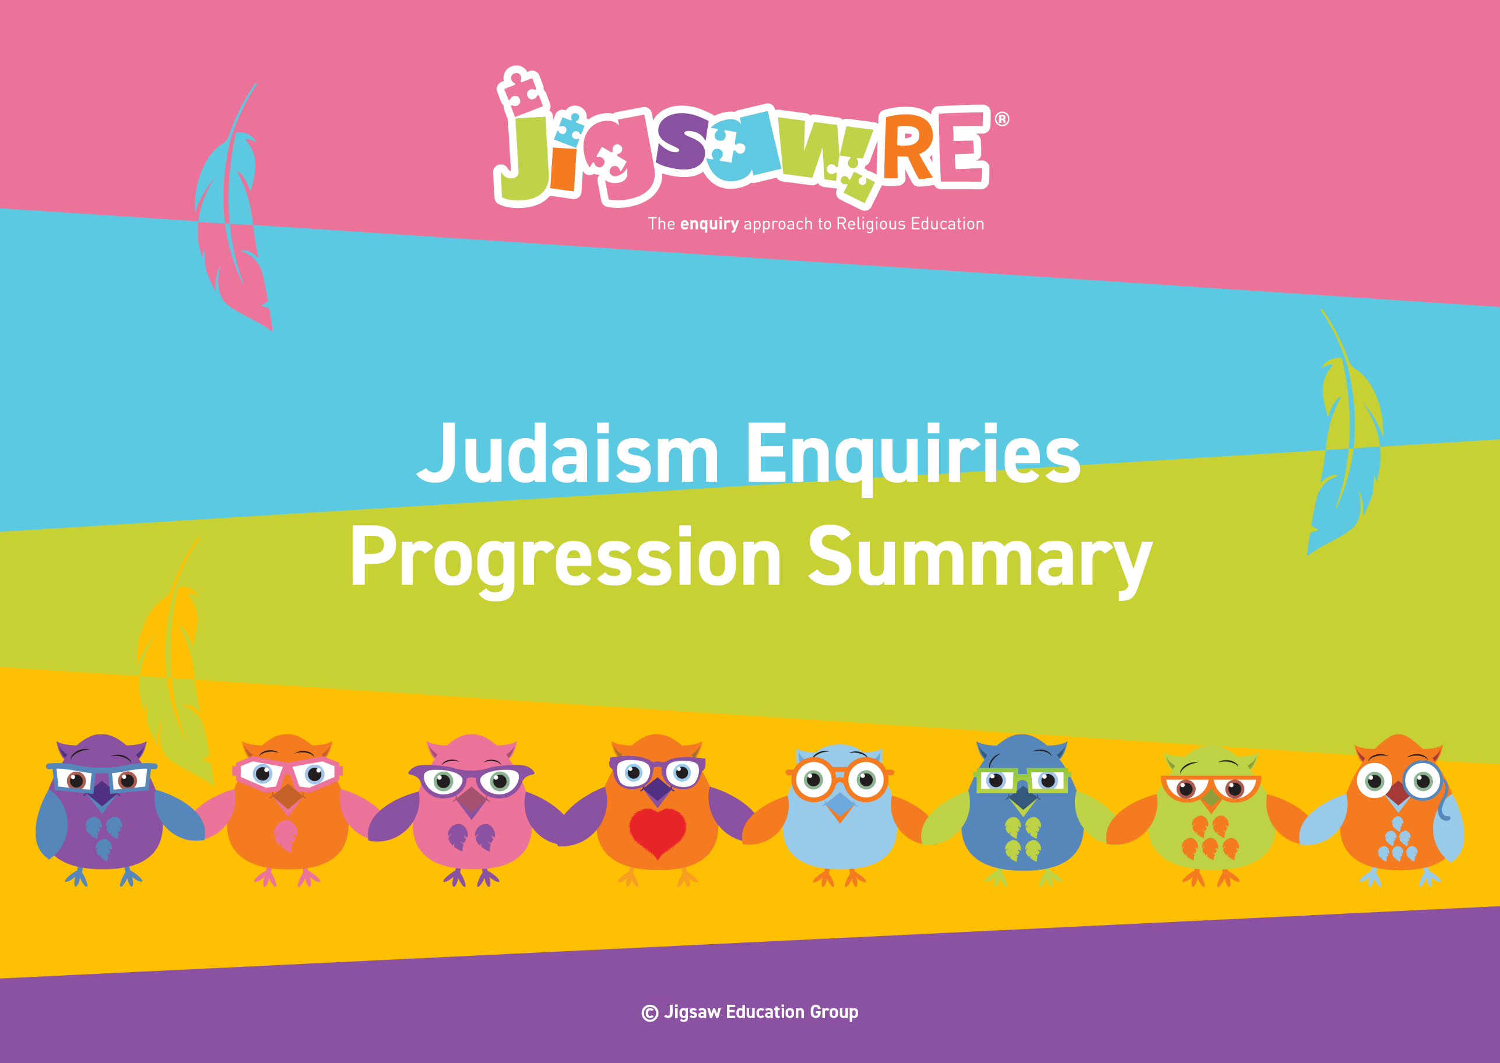


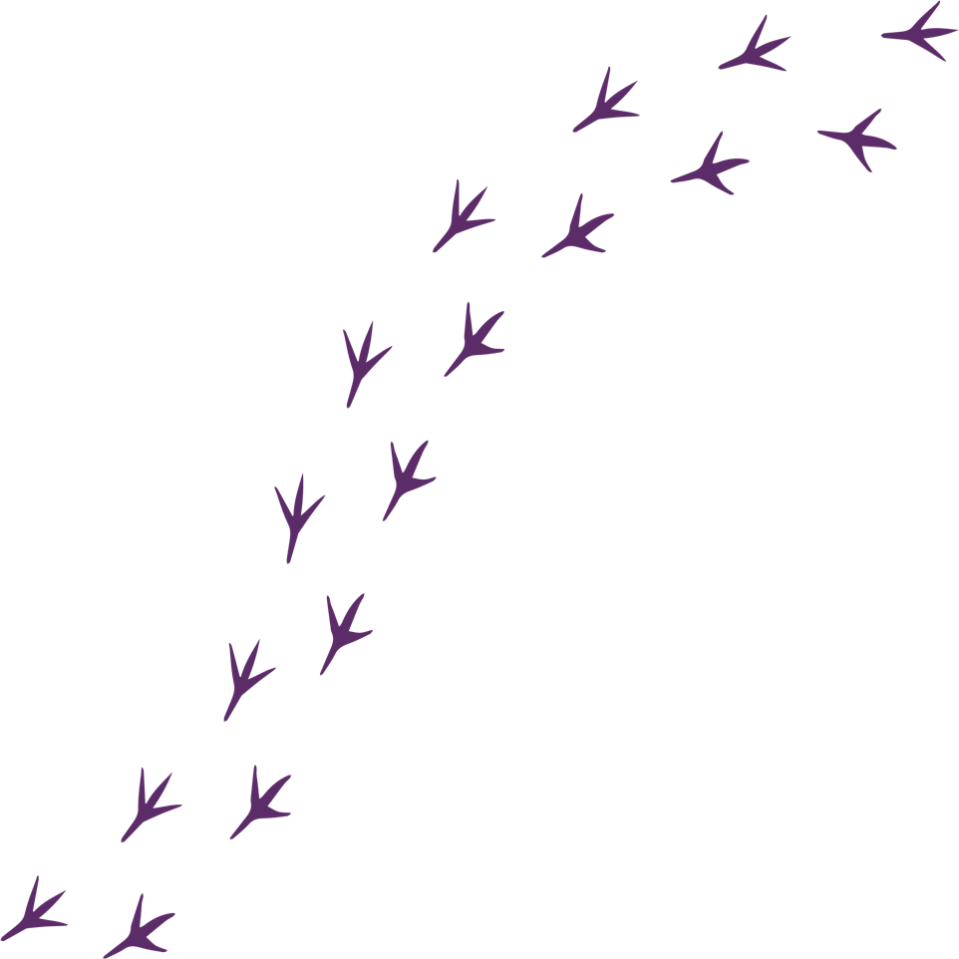
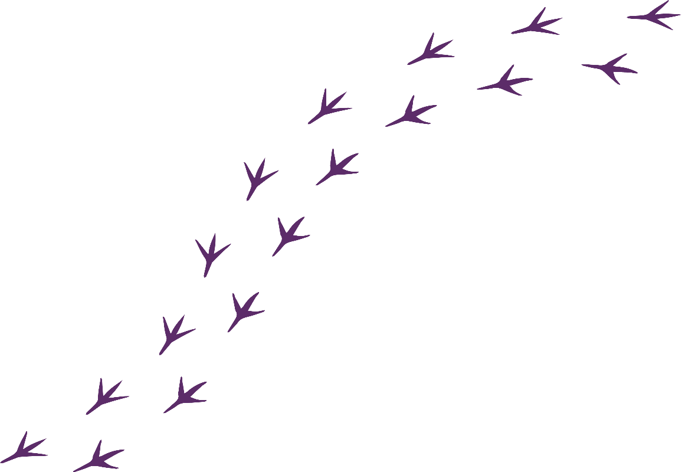
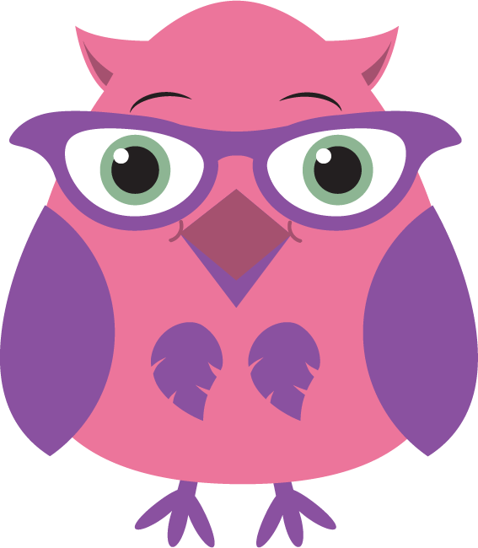

Judaism Enquiries Progression Summary

This document collects the relevant assessment statements and key vocabulary for the Worldview in one place.
Schools can use this collated information for their own curriculum documents, such as progression maps and knowledge organisers.
This can be used alongside the knowledge organisers for each enquiry.
Schools will need to select only from which of these enquiries they have chosen to teach.
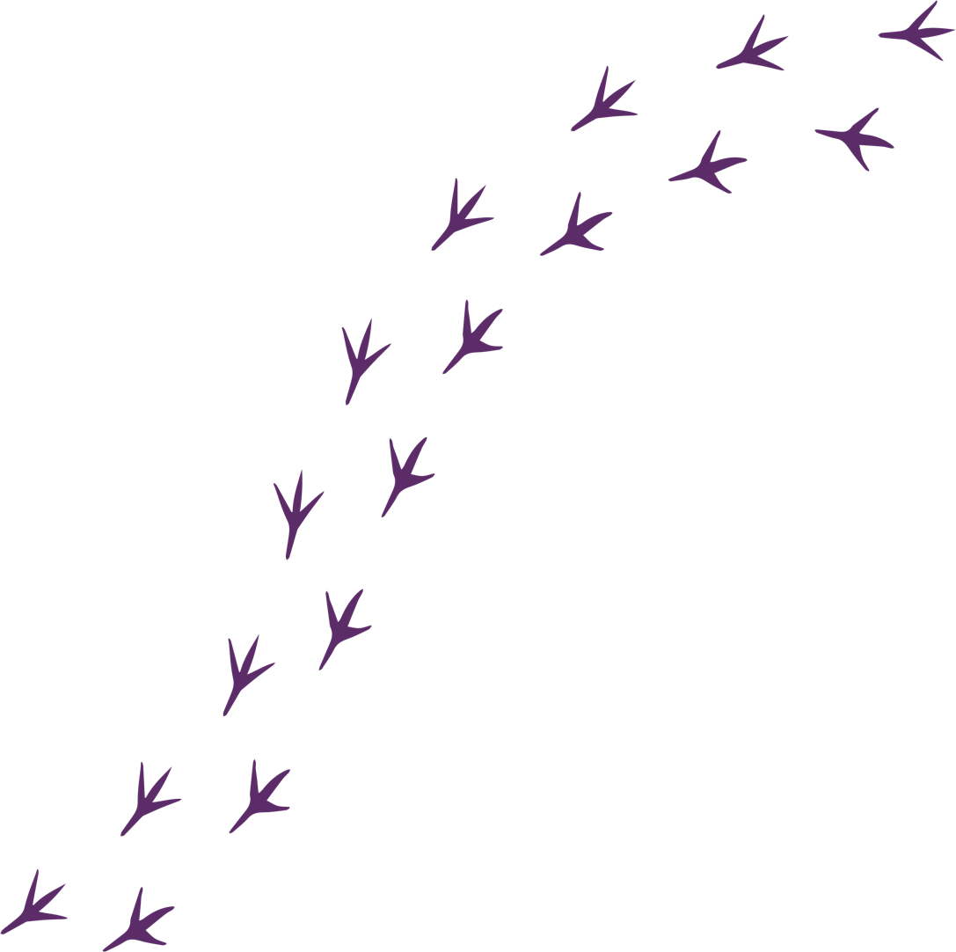
The ‘I can’ statements represent a child working at expected levels for their age groups. ‘I am starting to’ statements indicate areas where children may be showing Working Beyond. These can also be found within each individual enquiry, alongside further statements for Working Below and Working Beyond (see assessment descriptors for more detail about exact judgements for each Enquiry).
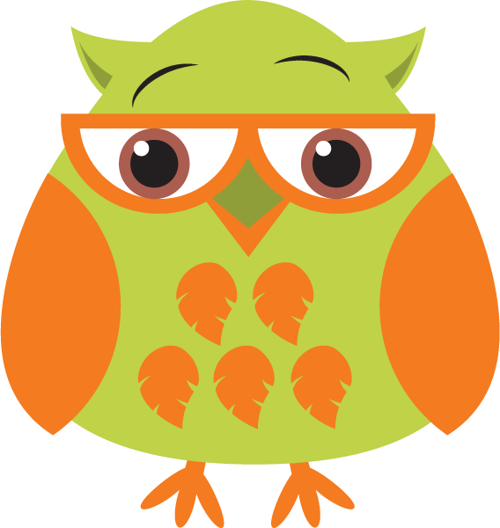
The black statements are more generic progression of skills statements within the 3 areas of learning.
These will apply to whichever enquiries and Worldviews are chosen.

Enquiry | Area of Learning:  Personal, Emotional and Social Development | Area of Learning:  Understanding the World | Area of Learning:  Communication and Language | Bridge Concept  &  Key Vocabulary
  EYFS (F1)  Piece 4  What makes people special to me and others? | Develop their sense of responsibility and membership of a community.  Play with one or more children, extending and elaborating play ideas.  Talk about their feelings using words like 'happy', 'sad', 'angry' or 'worried'.  Begin to understand how others might be feeling. | I know the story of Moses as a baby.  Talk about what they see using a wide vocabulary.  Begin to make sense of their own life-story and family's history.  Continue to develop positive attitudes about the differences between people. | Enjoy listening to longer stories and can remember much of what happens.  Use a wider range of vocabulary.  Be able to express a point of view and to debate when they disagree with an adult or a friend, using words as well as actions. | Bridge Concept: Special People  - religion  - faith  - worldview  - important  - Jew  - Jewish  - Moses
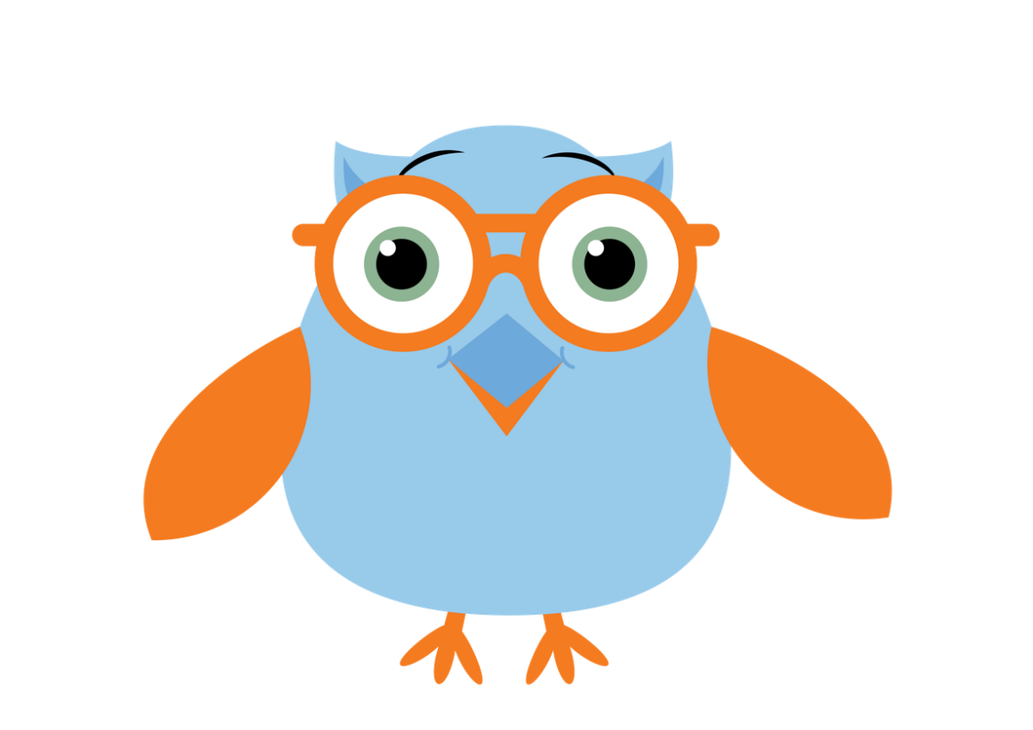

EYFS (F1)  Piece 5  What makes places special to me and others? | Develop their sense of responsibility and membership of a community.  Play with one or more children, extending and elaborating play ideas.  Begin to understand how others might be feeling. | Talk about what they see using a wide vocabulary.  Continue to develop positive attitudes about the differences between people. | Use a wider range of vocabulary.  Understand 'why' questions like: "Why do you think the caterpillar got so fat?"  Be able to express a point of view and to debate when they disagree with an adult or a friend, using words as well as actions. | Bridge Concept: Special Places  - Kippah  - Synagogue  - Jews  - Jewish  - worship  - prayer



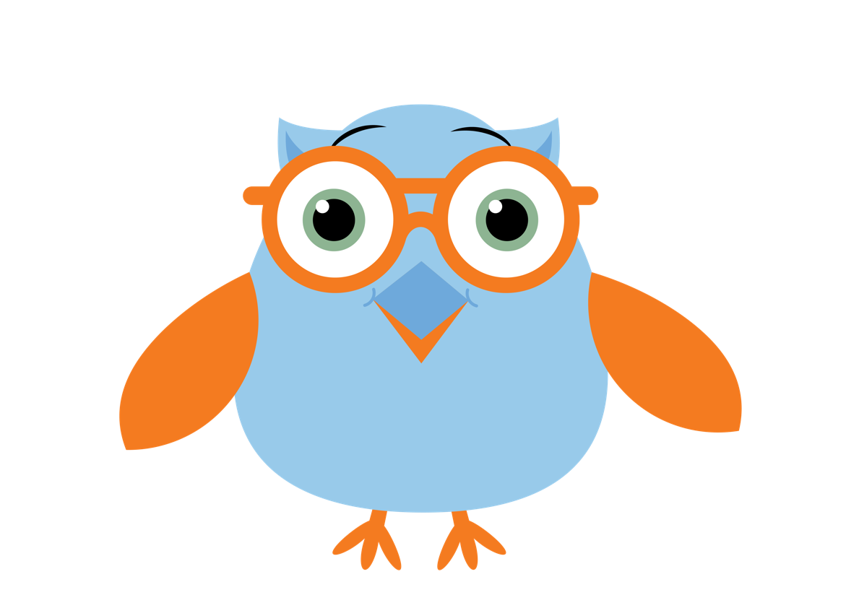

EYFS (F2)  Piece 4  What makes people special? | Build constructive and respectful relationships.  Express their feelings and consider the feelings of others.  Identify and moderate their own feelings socially and emotionally.  Think about the perspectives of others. | I know the story of Moses and the 10 Commandments (Exodus 10).  Compare and contrast characters from stories, including figures from the past.  Recognise that people have different beliefs and celebrate special times in different ways. | Understand how to listen carefully and why listening is important.  Learn new vocabulary.  Ask questions to find out more and to check they understand what has been said to them.  Describe events in some detail.  Use talk to help work out problems and organise thinking and activities explain how things work and why they might happen.  Engage in story times.  Listen to and talk about stories to build familiarity and understanding.  Retell the story once they have developed a deep familiarity with the text; some as exact repetition and some in their own words. | Bridge Concept: Special people  - rules  - Moses  - Ten Commandments  - religion  - Judaism  - Jews  - God  - role model

EYFS (F2)  Piece 6  What makes places special? | Build constructive and respectful relationships.  Express their feelings and consider the feelings of others.  Identify and moderate their own feelings socially and emotionally. Think about the perspectives of others.  Think about the perspectives of others. | Talk about members of their immediate family and community.  Name and describe people who are familiar to them.  Understand that some places are special to members of their community.  Recognise that people have different beliefs and celebrate special times in different ways. | Understand how to listen carefully and why listening is important.  Learn new vocabulary.  Ask questions to find out more and to check they understand what has been said to them.  Describe events in some detail.  Use talk to help work out problems and organise thinking and activities explain how things work and why they might happen. | Bridge Concept: Special Places  - Kippah  - Synagogue  - Jews  - Jewish  - God  - worship  - prayer

Enquiry | Green Descriptors:  Personal resonance with or reflection on the concept/belief underlying the subject matter of the enquiry. The child’s own thoughts, opinions, belief, empathy.  (personal development) | Blue Descriptors:  Knowledge and understanding of the subject matter of that enquiry (substantive/ subject knowledge) | Red Descriptors:  Skills of evaluation, research, critical thinking in relation to the enquiry question  (disciplinary knowledge) | Bridge Concept  &  Key Vocabulary
Years 1/2  Judaism  Generic Descriptors | I can tell you/talk about what concepts like special people/objects and respect mean to me in my world.  I can verbalise and/or express my own thoughts and feelings.  I am starting to see similarities/differences between my thoughts/feelings and other peoples’. | I am starting to use the religious vocabulary from the enquiry.  I can recall knowledge about the worldview I have studied.  I am starting to explain the significance and meaning of the learning, practices etc. | I can start to think through the enquiry question using some knowledge I have learned about the Worldview.  I am starting to see there could be more than one answer. | - Jews  - Judaism  - Torah  - Rabbi  - synagogue  - Star of David  - God
Years 1/2  Judaism  Enquiry 1  Who is God to the Jews? | I can say what rules I follow in my life (Enquiry 1)  I can explain why agreements are important and why they should be kept (Enquiry 1)  I am starting to think about rules I choose to keep and say why they are important to me (Enquiry 1) | I know the stories of Abraham and the Idols, Abrahams Covenant with God, Moses leading the slaves out of Egypt and Moses and the Ten Commandments. (Enquiry 1)  I can say why Abraham and Moses are important to Jewish people today (Enquiry 1) | I can talk about an agreement Jewish people make with God and begin to explain why this is important (Enquiry 1)  I am starting to say why these covenants might make Jewish people feel they have a special relationship with God (Enquiry 1) | Bridge Concept: Trust  - trust  - agreement  - rules  - charter  - promise  - God  - agreement  - Covenant  - Abraham  - Ten Commandments  - rules  - Canaan  - journey  - consequences  - Mount Sinai  - Moses  - Mitzvah/Mitzvot

Years 1/2  Judaism  Enquiry 2  Is Shabbat important to Jewish children? | I can tell you which is my favourite day of the week and talk about food I would like to share in a special meal (Enquiry 2) | I know The Creation Story from Genesis (Enquiry 1)  I can use the right names for things that are special to Jewish people during Shabbat and explain why (Enquiry 2) | I can start to make a connection between being a Jewish child and decisions about behaviour or actions (Enquiry 2) | Bridge Concept: Priorities  - priority  - routine  - sacrifice  - creation  - sabbath  - commandment  - Shabbat  - Challah bread  - Kiddush cup  - wine  - blessing  - prayer  - Kippah  - Havdalah candle  - spice box  - Shalom

Years 1/2  Judaism  Enquiry 3  Does visiting the synagogue help Jewish children feel closer to God? | I can talk about a place that is special to me (Enquiry 3)  I can explain feelings I have when I visit a place that is special to me (Enquiry 3) | I can explain what happens when Jews visit the synagogue for worship and prayer (Enquiry 3)  I am starting to name items at the Synagogue and explain how they are used (Enquiry 3) | I can talk about how Jewish children may feel closer to God if they visit the synagogue (Enquiry 3)  I am starting to explain reasons why a Jewish child might feel closer to God in the synagogue (Enquiry 3) | Bridge Concept: Special Places  - feelings  - emotions  - activities  - atmosphere  - appearance  - Ark  - Yad  - Hebrew  - Bimah  - Ner tamid  - Tallit  - Kippah/Kippur  - Mezuzah  - Western Wall/Wailing Wall  - Jerusalem  - Temple  - Reform  - Orthodox  - Tanakh  - sofer  - mantle  - mitzvah  - prayer  - community  - celebrate
Enquiry | Green Descriptors:  Personal resonance with or reflection on the concept/belief underlying the subject matter of the enquiry. The child’s own thoughts, opinions, belief, empathy.  (personal development) | Area of Learning:  Knowledge and understanding of the subject matter of that enquiry (substantive/ subject knowledge) | Area of Learning:  Skills of evaluation, research, critical thinking in relation to the enquiry question  (disciplinary knowledge) | Bridge Concept  &  Key Vocabulary
Years 3/4  Judaism  Generic Descriptors | I can tell you/talk about the concept/belief (e.g. relationships, authority and belonging) and start to relate this to the worldview I am studying.  I can express my own opinions and start to support them with rationales.  I can suggest similarities/differences between my thoughts/feelings and other peoples’. | I am using key religious vocabulary.  I can recall knowledge about the worldview I have studied.  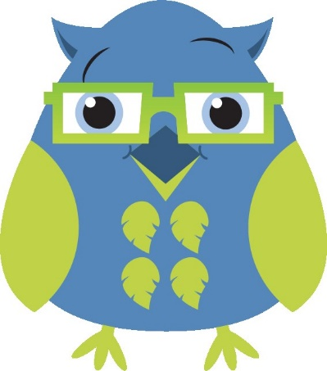  I can select the knowledge that is most significant to the enquiry and start to explain its relevance and importance. | I can start to think through the enquiry question using some knowledge I have learned about the Worldview.  I am starting to see there could be more than one answer. | - Jews  - Judaism  - Torah  - Rabbi  - synagogue  - Star of David  - God
Years 3/4  Judaism  Enquiry 1  What is the best way for Jews to live a good life? | I can give you examples of things I do to live a good life and explain which ones are more or less important to me (Enquiry 1) | I know the story of Abraham and Isaac (Enquiry 1)  I can describe some of the ways that Jews choose to live a good life and consider that they do this in different ways (Enquiry 1)  I am starting to choose and evaluate actions a Jew might take to lead a good life (Enquiry 1) | I can express an opinion on which ways I think might be the best ways for Jews to live a good life and start to give reasons (Enquiry 1) | Bridge Concept: Special Relationships  - agreement  - Rules Charter  - contract  - relationship  - trust  - commitment  - Abraham  - Isaac  - sacrifice  - lamb  - wedding  - marriage  - ceremony  - promise  - (c)huppah  - kippah  - vows  - sincerity  - ketubah  - Mitzvoth  - Mitzvah Day  - Tikkun olam  - Tu B’Shevat  - The 10 commandments  - Worship  - Shabbat
Years 3/4  Judaism  Enquiry 2  How do Jewish beliefs, teachings and stories impact on daily life? | I can discuss why I would choose to follow an instruction not to eat certain foods, whom I would listen to and why (Enquiry 2) | I know the story of Moses and the story of Passover. (Enquiry 2)  I can describe some of the things Jews do to show how their beliefs and respect for God impacts on their daily life (Enquiry 2) | I can identify how it might feel to keep Kashrut (Enquiry 2) | Bridge Concept: Authority  - food  - decision  - choices  - respect  - authority  - halal  - kosher  - vegan  - vegetarian  - Kashrut  - trief  - parev  - mitzvot  - Passover  - Seder meal  - Seder plate  - plagues  - Pescah  - unleavened  - Karpass  - Zro'a  - Marror  - Charoset  - Matzah
Years 3/4  Judaism  Enquiry 3  Does celebrating Shavuot help Jewish children feel closer to God? | I can talk about my celebrations (Enquiry 3)  I can reflect on celebrations and say why they are special (Enquiry 3) | I know the Sheema Prayer (Enquiry 3)  I can recall the Ten Commandments (Enquiry 3)  I recall the main story of Shavuot and talk about some of the key beliefs and practices (Enquiry 3) | I can reflect on the Shavuot festival and explain how a child may feel when they take part in Shavuot activities (Enquiry 3)  I can explain how some aspects of Shavuot may help a Jewish child feel closer to God (Enquiry 3) | Bridge Concept: Belonging  - belonging  - ceremony  - club  - celebrate  - logo  - organisation  - rite  - 10 Commandments  - Passover  - Shavuot  - Tikkun  - Bikkurim  - festival  - harvest  - pilgrimage  - Shema  - tefillin  - mezuzah  - tallit  - prayer  - sacred  - affirmation  - promise  - relationship
Enquiry | Green Descriptors:  Personal resonance with or reflection on the concept/belief underlying the subject matter of the enquiry. The child’s own thoughts, opinions, belief, empathy.  (personal development) | Area of Learning:  Knowledge and understanding of the subject matter of that enquiry (substantive/ subject knowledge) | Area of Learning:  Skills of evaluation, research, critical thinking in relation to the enquiry question  (disciplinary knowledge) | Bridge Concept  &  Key Vocabulary
Years 5/6  Judaism  Generic Descriptors | I can explain how this key concept/belief (e.g. forgiveness, responsibility and diversity) resonates in my own life and can also see this might be different for other people because of their worldview.  I can express my own thoughts and feelings clearly, having reflected on them.  I can compare my own worldview to others’. | I am using key religious vocabulary from this enquiry and previous learning.  I can recall knowledge about worldviews and explain differences in practice and interpretation within and between worldviews. | I can weigh up evidence from different sources and consider different aspects in my answer to the enquiry question.  I can discuss the diversity of different beliefs and link it to the knowledge learnt in the enquiry.  I express my answer supported by evidence and/or a rationale. | - Jews  - Judaism  - Torah  - Rabbi  - synagogue  - Star of David  - God
Years 5/6  Judaism  Enquiry 1  Are Rosh Hashanah and Yom Kippur important to Jewish children? | I can tell you about a time I said sorry (Enquiry 1)  I can start to explain how I choose to say sorry and ask for forgiveness (Enquiry 1) | I know the story of Moses and the Golden Calf (Exodus 32-34) (Enquiry 1)  I know the Al-Chet Prayer (Enquiry 1)  I can tell you about something that Jewish children might do at Rosh Hashanah or Yom Kippur (Enquiry 1)  I can explain why Rosh Hashanah and Yom Kippur are important to Jewish children (Enquiry 1) | I can explain the importance of some of the rituals and traditions at Rosh Hashanah and Yom Kippur and start to understand how they are linked to Jewish beliefs (Enquiry 1)  I am starting to explain my thinking around the rituals I have chosen, and consider what asking for forgiveness is like for Jewish children (Enquiry 1) | Bridge Concept: Forgiveness  - Forgive  - Forgiveness  - Sorry  - Apologise  - Emotions  - Celebrate  - New Year  - Rosh Hashanah  - Yom Kippur  - atonement  - judgement  - repentance  - Reflection  - Prayer  - Blessing  - Days of Awe  - Mitzvot  - Shofar  - Tashlich  - Kol Nidre  - Teshuvah

Years 5/6  Judaism  Enquiry 2  What is the best way for a Jew to show commitment to God? | I can express why showing commitment to something may be a good thing (Enquiry 2)  I can show an understanding of why people show commitment in different ways (Enquiry 2) | I can describe how different practices enable Jews to show their commitment to God and understand that some of these will be more significant to some Jews than others (Enquiry 2) | I can explain why I think some ways of showing commitment to God might be better than others for Jews (Enquiry 2)  I am starting to explain that individuals choose to show different degrees of commitment to their religion (Enquiry 2) | Bridge Concept: Responsibility and Commitment  - Promise  - effort  - Dedication  - Patience  - Responsibility  - Commitment  - Covenant  - Ten commandments  - Shabbat  - Kashrut  - Worship  - Seder  - Festivals  - Tallit  - Yad  - Mitzvah  - Bar Mitzvah  - Bat Mitzvah  - Ceremony  - Mitzvah project  - Rites of passage  - milestone  - denomination
Years 5/6  Judaism  Enquiry 3  How are sacred teachings and stories interpreted by Jews today? | I can explain how some stories and teachings can teach people about what is important and how to behave (Enquiry 3) | I know key stories from Genesis (The Seventh Day) and Exodus (The Sabbath Day) (Enquiry 3)  I can recognise that stories and teachings can be an important way of expressing belief and meaning and can explain the relevance of a Jewish story or sacred text (Enquiry 3)  I am starting to explain the impact of Jewish stories and holy texts on the life of a Jew today (Enquiry 3) | I can explain how some stories and texts can teach Jews about what is important in life and relate this to different communities within Judaism (Enquiry 3)  I am starting to give examples of how Jewish communities may choose to interpret the messages from the teachings I have chosen (Enquiry 3) | Bridge Concept: Diversity  - Diversity  - choice  - Difference  - Respect  - Celebrate  - Shabbat /Sabbath  - Challah  - Orthodox  - Reform  - Strands  - Haredi  - Masorti  - Liberal  - Tanakh  - Talmud  - Sefer Torah  - Yad  - Kashrut  - Kosher  - Trief  - rules  - symbol  - theme

