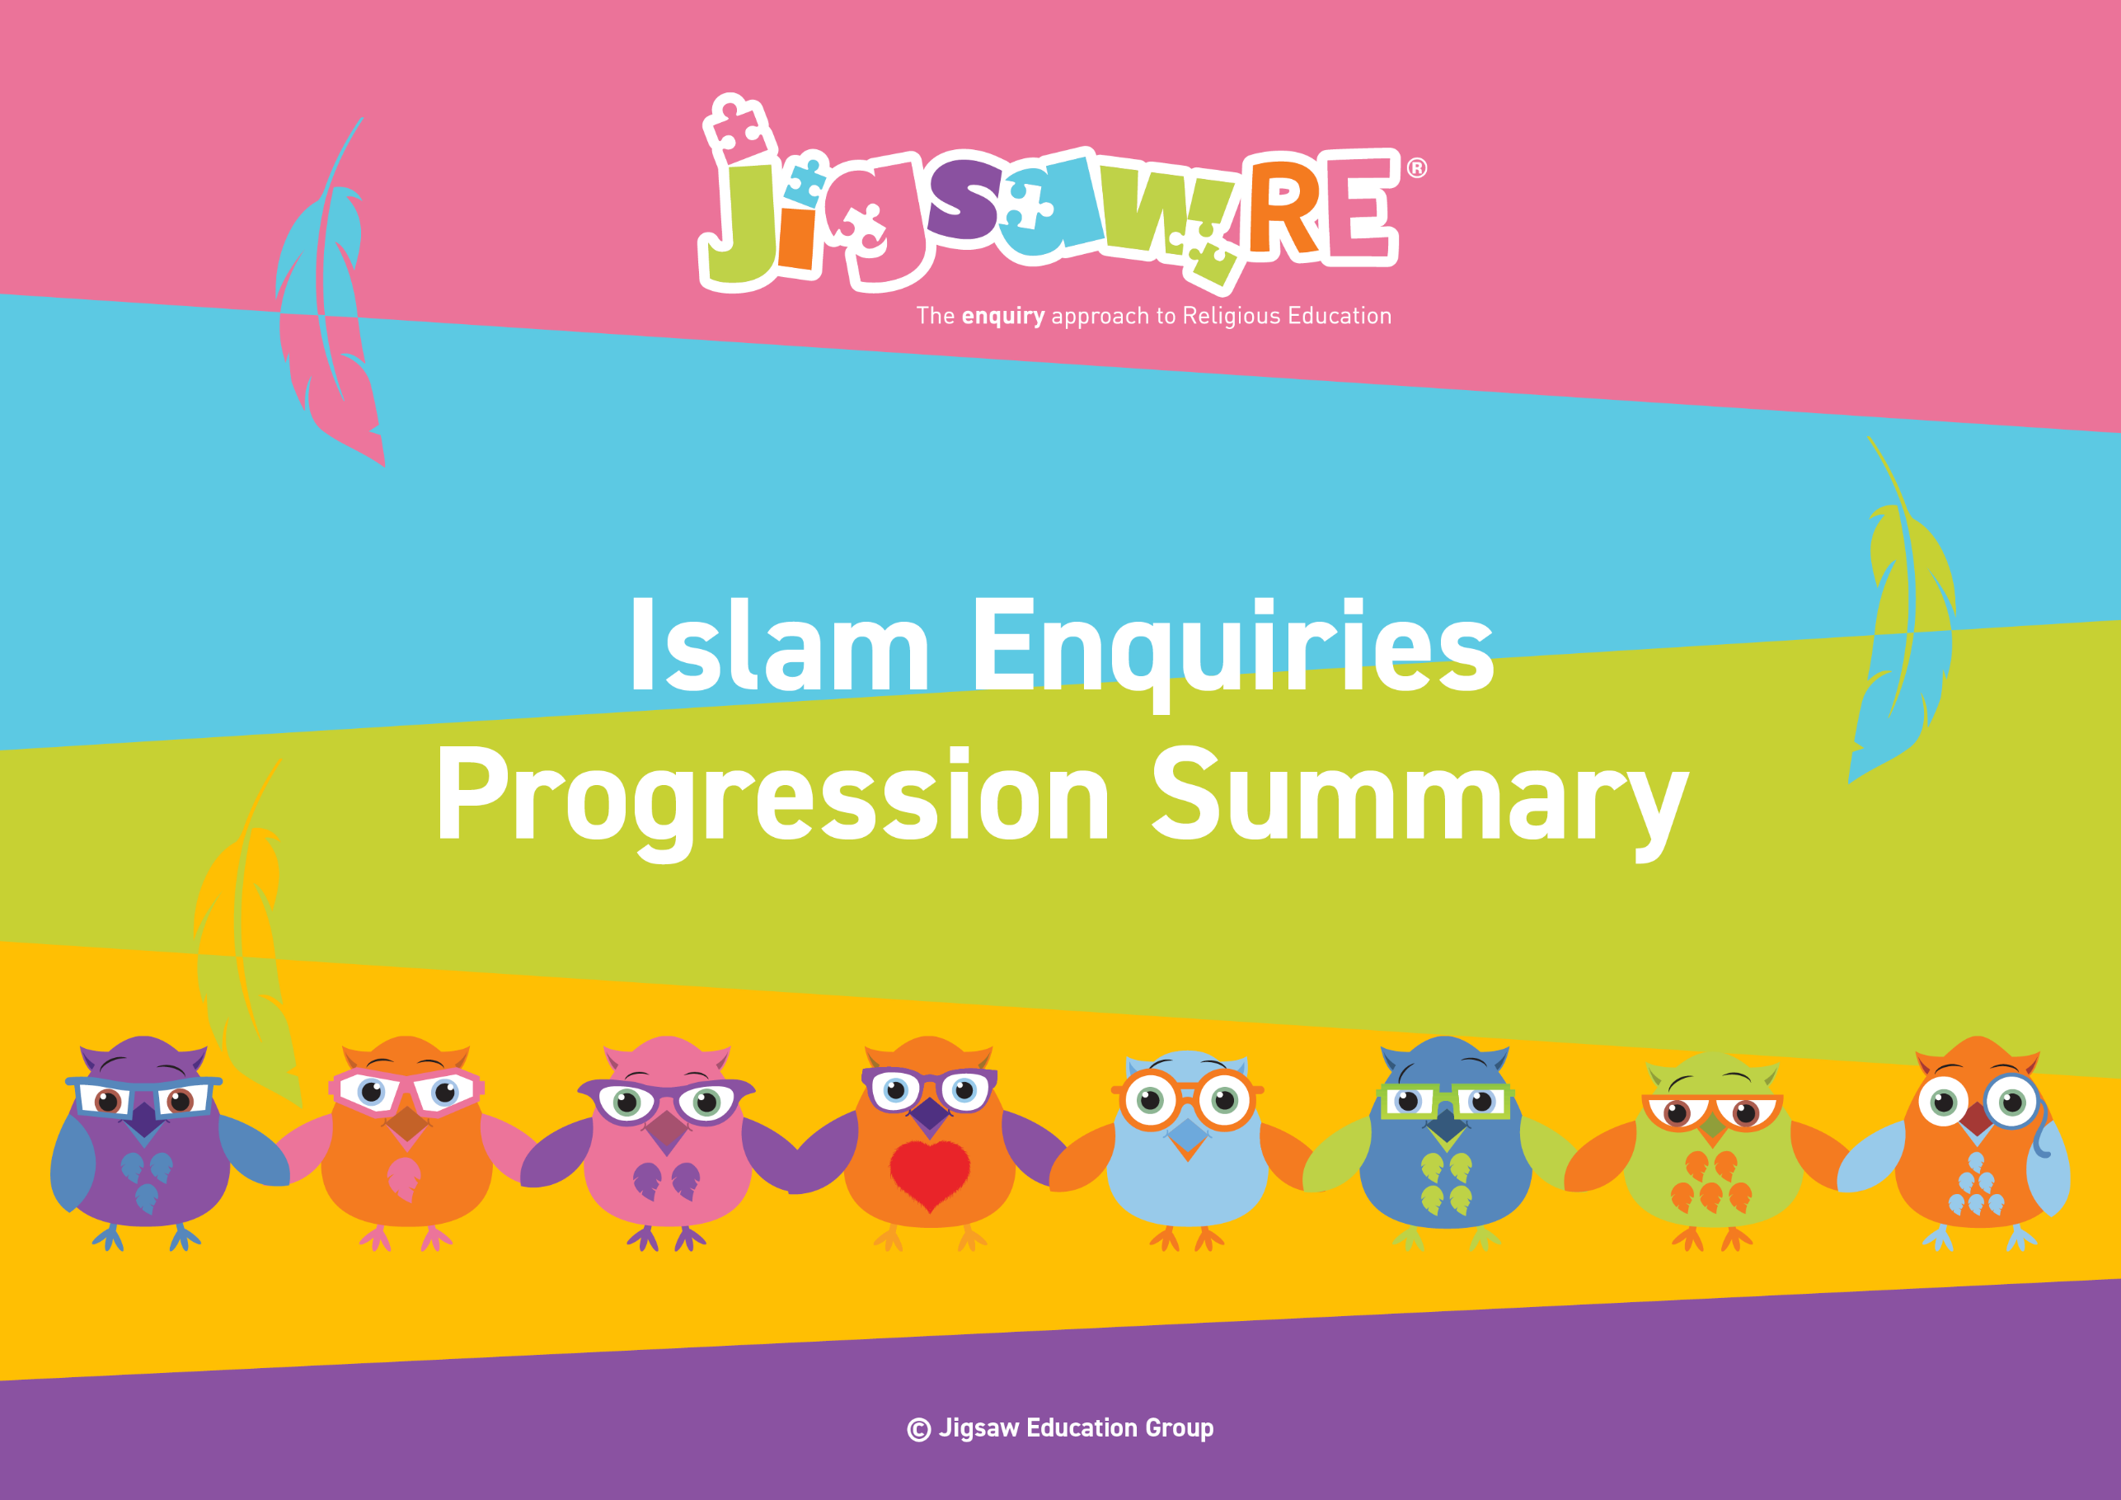







Islam Enquiries Progression Summary

This document collects the relevant assessment statements and key vocabulary for the Worldview in one place.
Schools can use this collated information for their own curriculum documents, such as progression maps and knowledge organisers.
This can be used alongside the knowledge organisers for each enquiry.
Schools will need to select only from which of these enquiries they have chosen to teach.


The ‘I can’ statements represent a child working at expected levels for their age groups. ‘I am starting to’ statements indicate areas where children may be showing Working Beyond. These can also be found within each individual enquiry, alongside further statements for Working Below and Working Beyond (see assessment descriptors for more detail about exact judgements for each Enquiry).

The black statements are more generic progression of skills statements within the 3 areas of learning. These will apply to whichever enquiries and Worldviews are chosen.

Enquiry | Area of Learning:  Personal, Emotional and Social Development | Area of Learning:  Understanding the World | Area of Learning:  Communication and Language | Bridge Concept  &  Key Vocabulary
  EYFS (F1)  Piece 3 | Develop their sense of responsibility and membership of a community.  Play with one or more children, extending and elaborating play ideas.  Talk about their feelings using words like 'happy', 'sad', 'angry' or 'worried'.  Begin to understand how others might be feeling. | I know the story of Bilal and the Beautiful Butterfly.  Talk about what they see using a wide vocabulary.  Continue to develop positive attitudes about the differences between people.  Know there are different countries in the world and talk about the differences they have experienced or seen in photos. | Enjoy listening to longer stories and can remember much of what happens.  Use a wider range of vocabulary.  Understand 'why' questions like: "Why do you think the caterpillar got so fat?"    Know many rhymes, be able to talk about familiar books, and be able to tell a long story.  Be able to express a point of view and to debate when they disagree with an adult or a friend, using words as well as actions. | Bridge Concept: Stories  - Story  - Moral  - Life Cycle  - Butterfly  - Allah  - Muslim  - Creation
EYFS (F1)    Piece 4 | Develop their sense of responsibility and membership of a community.  Play with one or more children, extending and elaborating play ideas.  Begin to understand how others might be feeling. | Talk about what they see using a wide vocabulary.  Continue to develop positive attitudes about the differences between people. |   Use a wider range of vocabulary.  Understand 'why' questions like: "Why do you think the caterpillar got so fat?"  Be able to express a point of view and to debate when they disagree with an adult or a friend, using words as well as actions. | Bridge Concept: Special Places  - Mosque  - Muslims  - Islam  - Allah
EYFS (F2)  Piece 3 | Build constructive and respectful relationships.  Express their feelings and consider the feelings of others.  Think about the perspectives of others. | I know the story of Bilal and the Beautiful Butterfly.  Compare and contrast characters from stories, including figures from the past.  Recognise that people have different beliefs and celebrate special times in different ways. | Understand how to listen carefully and why listening is important.  Learn new vocabulary.  Ask questions to find out more and to check they understand what has been said to them.  Describe events in some detail.  Use talk to help work out problems and organise thinking and activities explain how things work and why they might happen.  Engage in story times.  Listen to and talk about stories to build familiarity and understanding.  Retell the story once they have developed a deep familiarity with the text; some as exact repetition and some in their own words. | Bridge Concept: Stories  - Story  - moral  - creation  - Muslim  - Islam  - Allah
EYFS (F2)  Piece 4 | Build constructive and respectful relationships.  Express their feelings and consider the feelings of others.  Identify and moderate their own feelings socially and emotionally. Think about the perspectives of others. | Talk about members of their immediate family and community.  Name and describe people who are familiar to them.  Understand that some places are special to members of their community.  Recognise that people have different beliefs and celebrate special times in different ways. | Understand how to listen carefully and why listening is important.  Learn new vocabulary.  Ask questions to find out more and to check they understand what has been said to them.  Describe events in some detail.  Use talk to help work out problems and organise thinking and activities explain how things work and why they might happen. | Bridge Concept: Special Places  - Mosque  - Muslim  - Islam  - Allah  - Worship  - Prayer  - Rules


Enquiry | Green Descriptors:  Personal resonance with or reflection on the concept/belief underlying the subject matter of the enquiry. The child’s own thoughts, opinions, belief, empathy.  (personal development) | Blue Descriptors:  Knowledge and understanding of the subject matter of that enquiry (substantive/ subject knowledge) | Red Descriptors:  Skills of evaluation, research, critical thinking in relation to the enquiry question  (disciplinary knowledge) | Bridge Concept  &  Key Vocabulary
Years 1/2  Islam  Generic Descriptors | I can tell you/talk about what concepts like special people/objects and respect mean to me in my world.  I can verbalise and/or express my own thoughts and feelings.  I am starting to see similarities/differences between my thoughts/feelings and other peoples’. | I am starting to use the religious vocabulary from the enquiry.  I can recall knowledge about the worldview I have studied.  I am starting to explain the significance and meaning of the learning, practices etc. | I can start to think through the enquiry question using some knowledge I have learned about the Worldview.  I am starting to see there could be more than one answer. | - Allah  - Muslims  - Qur’an  - Islam
Years 1/2  Islam  Enquiry 1  Who is God to Muslims? | I can tell you how I might show respect for other people (Enquiry 1)  I am starting to explain why the respect Allah is shown by Muslims is the same or different to how I show respect (Enquiry 1) | I can describe some of the attributes (names) of Allah and what these might mean (Enquiry 1) | I can explain how Muslims might show respect for these in their daily lives (Enquiry 1)  I am starting to explain the impact of this on the life of a Muslim today (Enquiry 1) | Bridge Concept: Respect  - Respect  - Attribute  - Deity  - Submission  - Perfect  - Powerful  - Provider  - Avenger  - Watchful  - Pilgrimage  - Compassionate  - Merciful  - Appreciation  - Effort
Years 1/2  Islam  Enquiry 2  How important is the prophet Muhammad to Muslims? | I can say who is special to me and say why (Enquiry 2) | I can identify key facts from the life of Muhammad (Enquiry 2)  I am starting to explain how events might impact on Muslims today (Enquiry 2) | I can say why I have chosen certain facts about Muhammad’s life above others (Enquiry 2)  I am starting to explain how a Muslim might feel about different events (Enquiry 2) | Bridge Concept: Special People  - Roles  - Prophet  - Compliment  - Honest  - Fair  - Patient  - Reliable  - Makkah  - Devoted  - Angel Jibr’il  - Respect  - Hadith  - Pbuh  - Role Model  - Special
Years 1/2  Islam  Enquiry 3  How important is the Qur'an to Muslims? | I can give examples of good things I could do in my life (Enquiry 3)  I am starting to use examples from my own life e.g. how a book may have helped me (Enquiry 3) | I know the story of the Night of Power from the Qur’an. (Enquiry 3)  I can explain why a Muslim might think the Qur’an is important (Enquiry 3)  I am starting to explain how Muslim’s actions are influenced by the Qur’an (Enquiry 3) | I can explain how instructions in the Qur’an might impact on the life of a Muslim today (Enquiry 3) | Bridge Concept: Stories  - Stories  - Respect  - Angel  - Angel Jibr’il  - Khadijah  - Makkah  - Noble  - Squander  - Night of Power  - Saudi Arabia
Enquiry | Green Descriptors:  Personal resonance with or reflection on the concept/belief underlying the subject matter of the enquiry. The child’s own thoughts, opinions, belief, empathy.  (personal development) | Area of Learning:  Knowledge and understanding of the subject matter of that enquiry (substantive/ subject knowledge) | Area of Learning:  Skills of evaluation, research, critical thinking in relation to the enquiry question  (disciplinary knowledge) | Bridge Concept  &  Key Vocabulary
Years 3/4  Islam  Generic Descriptors | I can tell you/talk about the concept/belief (e.g. commitment, special places, a good life) and start to relate this to the worldview I am studying.  I can express my own opinions and start to support them with rationales.  I can suggest similarities/differences between my thoughts/feelings and other peoples’. | I am using key religious vocabulary.  I can recall knowledge about the worldview I have studied.  I can select the knowledge that is most significant to the enquiry and start to explain its relevance and importance. | I can start to think through the enquiry question using some knowledge I have learned about the Worldview.    I am starting to see there could be more than one answer. | - Story  - Muslims  - Qur’an  - Islam
Years 3/4  Islam  Enquiry 1  Does praying at regular intervals help a Muslim in their everyday lives? | I can explain how commitment can be hard and can describe how it would feel to reach a goal (Enquiry 1) | I know the story of the Night Journey. (Enquiry 1)  I can describe the Muslim prayer routine and where they might choose to pray (Enquiry 1)  I am starting to give reasons to explain why Muslims might pray in different places (Enquiry 1) | I can explain how Muslims might be helped in their everyday lives by regular prayer (Enquiry 1) | Bridge Concept: Commitment  - Exercise  - Commitment  - Prayer (Salat/Salah)  - Thankfulness  - Self-discipline  - Respect  - Mosque  - Ka’bah  - Pilgrimage  - Hajj  - Dome, Minaret  - Washroom  - Important  - Forgotten  - Remembering
Years 3/4  Islam  Enquiry 2  Does completing a pilgrimage make a person a better Muslim? | I can consider a special journey I have taken or would like to take and explain the feelings it may cause (Enquiry 2) | I know the story of the Hijra. (Enquiry 2)  I can describe important places and actions on the Hajj (Enquiry 2)  I am starting to explain how some of the events during Hajj could help Muslims feel a sense of commitment to God (Enquiry 2) | I can consider if completing the Hajj makes a person a better Muslim and say why or why not (Enquiry 2) | Bridge Concept: Special Journeys  - Journey  - Preparation  - Ka’bah  - Makkah  - Pilgrimage  - Pilgrim  - Grand Mosque  - Mina  - Arafat  - Hajj  - Belonging  - Commitment  - Ummah  - Ihram
Years 3/4  Islam  Enquiry 3  What is the best way for a Muslim to lead a good life? | I can explain what living a good life means to me (Enquiry 3) | I can consider the different actions a Muslim might take to lead a good life (Enquiry 3) | I can explain the best ways I think a Muslim could lead a good life (Enquiry 3)  I am starting to explain why I think some actions lead to a better life than others (Enquiry 3) | Bridge Concept: A good life  - Good life  - Unselfish  - Ramadan  - Muhammad  - Zakat/Zakah  - Wealth  - Purify  - Sawm  - Fasting  - Charity  - Charities  - Volunteering
Enquiry | Green Descriptors:  Personal resonance with or reflection on the concept/belief underlying the subject matter of the enquiry. The child’s own thoughts, opinions, belief, empathy.  (personal development) | Area of Learning:  Knowledge and understanding of the subject matter of that enquiry (substantive/ subject knowledge) | Area of Learning:  Skills of evaluation, research, critical thinking in relation to the enquiry question  (disciplinary knowledge) | Bridge Concept  &  Key Vocabulary
Years 5/6  Islam  Generic Descriptors | I can explain how this key concept/belief (e.g. commitment, guidance, motivation) resonates in my own life and can also see this might be different for other people because of their worldview.  I can express my own thoughts and feelings clearly, having reflected on them.  I can compare my own worldview to others’. | I am using key religious vocabulary from this enquiry and previous learning.  I can recall knowledge about worldviews and explain differences in practice and interpretation within and between worldviews. | I can weigh up evidence from different sources and consider different aspects in my answer to the enquiry question.  I can discuss the diversity of different beliefs and link it to the knowledge learnt in the enquiry.  I express my answer supported by evidence and/or a rationale. | - Allah  - Qur’an  - Muslim  - Islam
Years 5/6  Islam  Enquiry 1  What is the best way for a Muslim to show commitment to God? | I can name a commitment that is important to me and say why it is important (Enquiry 1) | I can explain some of the ways that Muslims might show commitment to God (Enquiry 1)  I am starting to understand that some examples of commitment are more significant to some Muslims than others (Enquiry 1) | I can say which I think is the best way for a Muslim to show commitment to God and say why (Enquiry 1) | Bridge Concept: Commitment  - Commitment  - Belonging  - Ramadan  - Makkah  - Zakat  - Charity  - Purify  - Sawm (Fasting)  - Afterlife  - Akhirah  - Mosque  - Compassionate  - Merciful  - Dedication  - Effort
Years 5/6  Islam  Enquiry 2  How is the Qur’an vital to Muslims today? | I can explain what I have learnt from a text and how I might care for things which are important to me (Enquiry 2) | I know the story of the Night of Power. (Enquiry 2)  I can explain facts about the treatment of the Qur’an and how it was revealed (Enquiry 2)  I am starting to explain why the Qur’an is shown respect by the actions Muslims take (Enquiry 2) | I can explain how interpreting the Qur'an might be vital to how a Muslim chooses to live today (Enquiry 2) | Bridge Concept: Guidance and teachings  - Guidance  - Free will  - Consequences  - Surah  - Jibr’ail  - Muhammed  - Night of power  - Kursi  - Interpret  - Merciful  - Compassion  - Ayat  - Respect  - Special
Years 5/6  Islam  Enquiry 3  Does belief in Akhirah (life after death) help Muslims lead a good life? | I can give examples of times my choices have been influenced and may have changed when I considered the consequences that might follow (Enquiry 3)  I am starting to explain how my beliefs about life after death make a difference to how I see things (Enquiry 3) | I can explain how believing in Akhirah influences Muslims to do their best to lead good lives (Enquiry 3)  I am starting to explain different Muslim interpretations of Jihad and explore their justifications for these (Enquiry 3) | I can recognise what motivates or influences me to lead a good life and compare it with what motivates and influences Muslims (Enquiry 3)  I can explore my own and other people’s attitudes towards interpretations and recognise and challenge stereotyping (Enquiry 3) | Bridge Concept: Motivation  - Motivation  - Achievement  - Satisfaction  - Akhirah  - Surah  - Ayat  - Hadith  - Jihad  - Strive  - Struggle  - Vision

