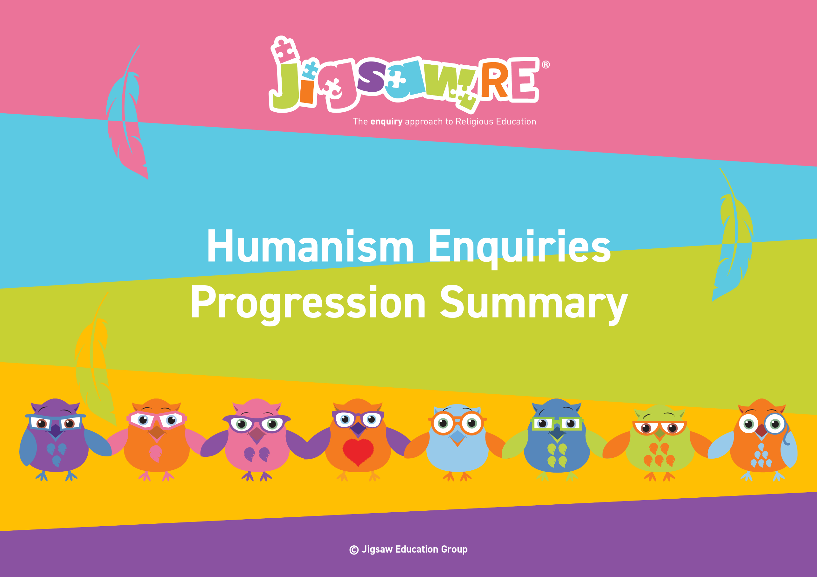





§


Humanism Enquiries Progression Summary

This document collects the relevant assessment statements and key vocabulary for the Worldview in one place.
Schools can use this collated information for their own curriculum documents, such as progression maps and knowledge organisers.
This can be used alongside the knowledge organisers for each enquiry.
Schools will need to select only from which of these enquiries they have chosen to teach.


The ‘I can’ statements represent a child working at expected levels for their age groups. ‘I am starting to’ statements indicate areas where children may be showing Working Beyond. These can also be found within each individual enquiry, alongside further statements for Working Below and Working Beyond (see assessment descriptors for more detail about exact judgements for each Enquiry).

The black statements are more generic progression of skills statements within the 3 areas of learning.
These will apply to whichever enquiries and Worldviews are chosen.

Enquiry | Green Descriptors:  Personal resonance with or reflection on the concept/belief underlying the subject matter of the enquiry. The child’s own thoughts, opinions, belief, empathy.  (personal development) | Blue Descriptors:  Knowledge and understanding of the subject matter of that enquiry (substantive/ subject knowledge) | Red Descriptors:  Skills of evaluation, research, critical thinking in relation to the enquiry question  (disciplinary knowledge) | Bridge Concept  &  Key Vocabulary
Years 1/2  Humanism  Generic Descriptors | I can tell you/talk about what concepts like special people/objects and respect mean to me in my world.  I can verbalise and/or express my own thoughts and feelings.  I am starting to see similarities/differences between my thoughts/feelings and other peoples’. | I am starting to use the religious vocabulary from the enquiry.  I can recall knowledge about the worldview I have studied.  I am starting to explain the significance and meaning of the learning, practices etc. | I can start to think through the enquiry question using some knowledge I have learned about the Worldview.  I am starting to see there could be more than one answer. | - Humanism  - Humanist  - Non-religious  - Worldview  - Happy Human
Years 1/2  Humanism  Enquiry 1  What do Humanists believe? | I can tell you how I might care for people, animals and the planet (Enquiry 1)   | I can say some things that Humanists might believe (Enquiry 1)  I am starting to remember the Golden Rule and what is means (Enquiry 1) | I can say how Humanists might act in their daily lives (Enquiry 1) |   Bridge Concept: Leading a Good Life  - Respect  - Rules  - Golden Rule  - Big Band  - curiosity  - Evolution/evolved  - Freedom  - Problem  - Solution  - Celebration  - Freedom  - Symbol  - Environment  - Food bank  - Resources  - Wildlife
Enquiry |   Green Descriptors:  Personal resonance with or reflection on the concept/belief underlying the subject matter of the enquiry. The child’s own thoughts, opinions, belief, empathy.  (personal development) | Area of Learning:  Knowledge and understanding of the subject matter of that enquiry (substantive/ subject knowledge) | Area of Learning:  Skills of evaluation, research, critical thinking in relation to the enquiry question  (disciplinary knowledge) | Bridge Concept  &  Key Vocabulary
Years 3/4  Humanism  Generic Descriptors | I can tell you/talk about the concept/belief (e.g. leading a good life) and start to relate this to the worldview I am studying.  I can express my own opinions and start to support them with rationales.  I can suggest similarities/differences between my thoughts/feelings and other peoples’. | I am using key religious vocabulary.  I can recall knowledge about the worldview I have studied.  I can select the knowledge that is most significant to the enquiry and start to explain its relevance and importance. | I can start to think through the enquiry question using some knowledge I have learned about the Worldview.  I am starting to see there could be more than one answer. | - Humanism  - Humanist  - Non-religious  - Worldview  - Happy Human
Years 3/4  Humanism  Enquiry 1  What motivates Humanists to lead good lives? | I can describe a time when I made somebody happy (Enquiry 1)  I can explain some actions a Humanist might take to lead a good life (Enquiry 1) | I can name a Humanist symbol (Enquiry 1)  I can explain some things that Humanists might believe (Enquiry 1) | I can explain how Humanists might act in their daily lives (Enquiry 1) | Bridge Concept: Leading a good life  - actions  - choices  - consequences  - atoms  - Big bang  - curiosity  - evolution/evolved  - freedom  - gases  - problem  - solution  - carbon  - climate  - global warming  - symbol  - environment  - food bank  - resources  - wildlife
Enquiry | Green Descriptors:  Personal resonance with or reflection on the concept/belief underlying the subject matter of the enquiry. The child’s own thoughts, opinions, belief, empathy.  (personal development) | Area of Learning:  Knowledge and understanding of the subject matter of that enquiry (substantive/ subject knowledge) | Area of Learning:  Skills of evaluation, research, critical thinking in relation to the enquiry question  (disciplinary knowledge) | Bridge Concept  &  Key Vocabulary
Years 5/6  Humanism  Generic Descriptors | I can explain how this key concept/belief (e.g. inspiration and role models) resonates in my own life and can also see this might be different for other people because of their worldview.  I can express my own thoughts and feelings clearly, having reflected on them.  I can compare my own worldview to others’. | I am using key religious vocabulary from this enquiry and previous learning.  I can recall knowledge about worldviews and explain differences in practice and interpretation within and between worldviews. | I can weigh up evidence from different sources and consider different aspects in my answer to the enquiry question.  I can discuss the diversity of different beliefs and link it to the knowledge learnt in the enquiry.  I express my answer supported by evidence and/or a rationale. | - Humanism  - Humanist  - Non-religious  - Worldview  - Happy Human
Years 5/6  Humanism  Enquiry 1  How do inspirational people impact on how Humanists live today? | I can explain something which has inspired me and how I live (Enquiry 1)  I am starting to discuss the impact of an inspirational person or experience on my life (Enquiry 1) | I can explain what a Humanist might find as an inspiration and say why (Enquiry 1) | I can explain how Humanists might act as a result of this inspiration (Enquiry 1) | Bridge Concept: Inspirations/Role Models  - actions  - impact  - inspiration  - role-model  - atheist  - Physics  - Nobel Prize  - evolution  - naturalist  - natural selection  - anatomist  - anthropologist  - archaeology  - palaeopathology  - skeleton  - ethical  - criteria  - commonality  - difference  - inspirational

