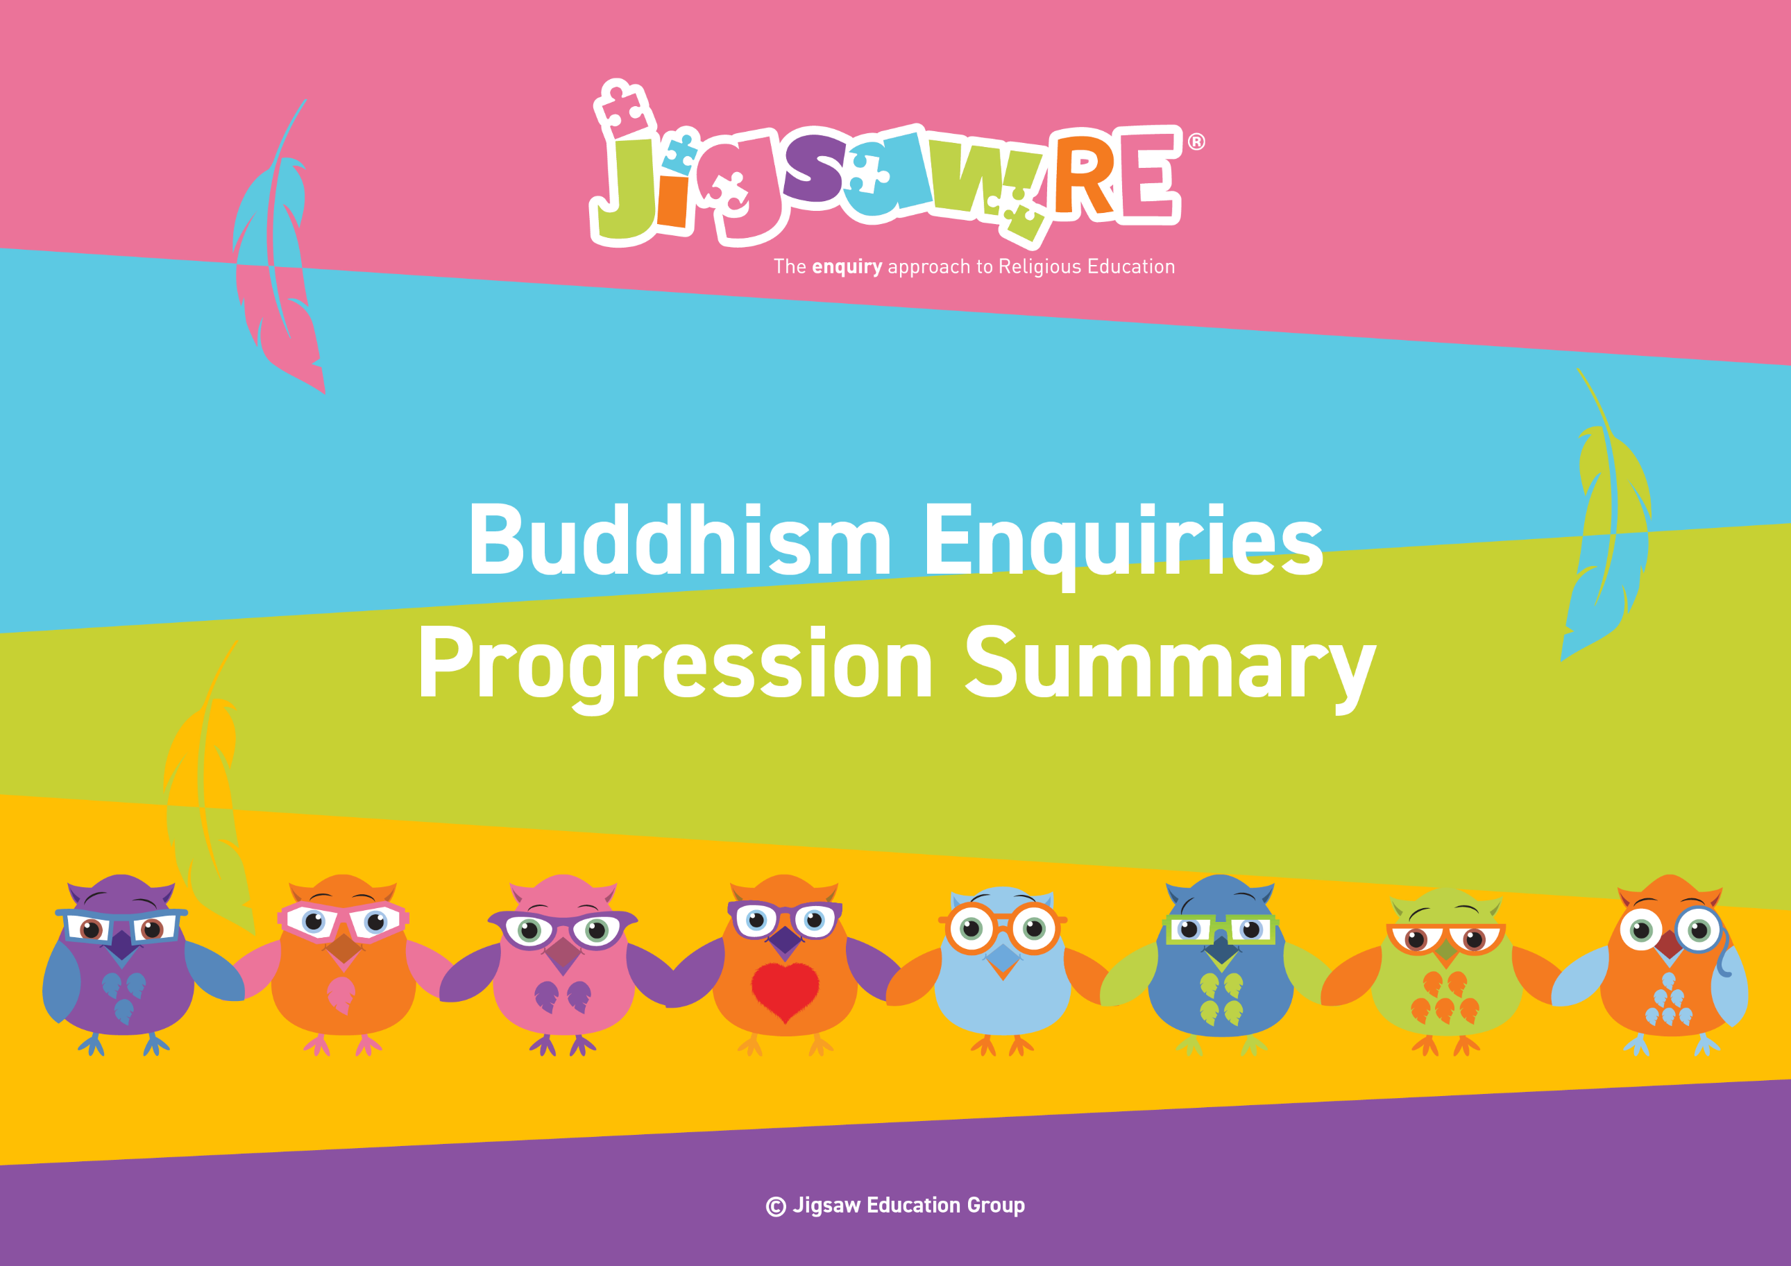







Buddhism Enquiries Progression Summary

This document collects the relevant assessment statements and key vocabulary for the Worldview in one place.
Schools can use this collated information for their own curriculum documents, such as progression maps and knowledge organisers.
This can be used alongside the knowledge organisers for each enquiry.
Schools will need to select only from which of these enquiries they have chosen to teach.


The ‘I can’ statements represent a child working at expected levels for their age groups. ‘I am starting to’ statements indicate areas where children may be showing Working Beyond. These can also be found within each individual enquiry, alongside further statements for Working Below and Working Beyond (see assessment descriptors for more detail about exact judgements for each Enquiry).

The black statements are more generic progression of skills statements within the 3 areas of learning.
These will apply to whichever enquiries and Worldviews are chosen.

Enquiry | Green Descriptors:  Personal resonance with or reflection on the concept/belief underlying the subject matter of the enquiry. The child’s own thoughts, opinions, belief, empathy.  (personal development) | Blue Descriptors:  Knowledge and understanding of the subject matter of that enquiry (substantive/ subject knowledge) | Red Descriptors:  Skills of evaluation, research, critical thinking in relation to the enquiry question  (disciplinary knowledge) | Bridge Concept  &  Key Vocabulary
Years 1/2  Buddhism  Generic Descriptors | I can tell you/talk about what concepts like special stories and good choices mean to me in my world.  I can verbalise and/or express my own thoughts and feelings.  I am starting to see similarities/differences between my thoughts/feelings and other peoples’. | I am starting to use the religious vocabulary from the enquiry.  I can recall knowledge about the worldview I have studied.  I am starting to explain the significance and meaning of the learning, practices etc. | I can start to think through the enquiry question using some knowledge I have learned about the Worldview.  I am starting to see there could be more than one answer. | - Buddha  - Enlightenment  - Buddhist  - Buddhism
Years 1/2  Buddhism  Enquiry 1    Why is the story of the Buddha important to some Buddhists? | I can talk about something I care for (Enquiry 1)  I can say how it felt to take care of something or somebody (Enquiry 1) | I can remember some parts of the life of the Buddha story and talk about them (Enquiry 1) | I can express an opinion about why the Buddha could be important to some Buddhists (Enquiry 1) |   Bridge Concept: Stories  - Story  - Moral  - Prince  - Siddartha  - Bodhi tree  - Suffering  - Selfishness  - Greed
Years 1/2  Buddhism  Enquiry 2  What is the best way for a Buddhist to lead a good life?  (Right Speech.) | I can say a way to use right speech (Enquiry 2)  I can say how it felt to use right speech (Enquiry 2) | I can remember some Buddhist teachings about right speech and talk about them (Enquiry 2) | I can express an opinion about what the Buddha taught about right speech and why it might be important to some Buddhists (Enquiry 2) | Bridge Concept: Behaving  - Four noble truths  - Noble Eightfold Path  - Greed  - Selfishness  - Suffering  - Meditation  - Mindfulness  - Right speech  - Truth  - Gossip  - Secret  - Suffering
Years 1/2  Buddhism  Enquiry 3  What is the best way for a Buddhist to lead a good life? Right action. | I can say how it felt to use right action (Enquiry 3) | I can say what Right Action means (Enquiry 3)  I can remember some Buddhist teachings about right action and talk about them (Enquiry 3) | I can express an opinion about right action and why it might be important  (Enquiry 3) | Bridge Concept: Actions and Words  - Teacher  - Instructions  - Guidance  - Teachings  - Actions  - Consequence  - Greed  - Selfishness  - Positive  - Suffering  - Environment
Enquiry |   Green Descriptors:  Personal resonance with or reflection on the concept/belief underlying the subject matter of the enquiry. The child’s own thoughts, opinions, belief, empathy.  (personal development) | Area of Learning:  Knowledge and understanding of the subject matter of that enquiry (substantive/ subject knowledge) | Area of Learning:  Skills of evaluation, research, critical thinking in relation to the enquiry question  (disciplinary knowledge) | Bridge Concept  &  Key Vocabulary
Years 3/4  Buddhism  Generic Descriptors | I can tell you/talk about the concept/belief (e.g. choices, happiness, and compassion) and start to relate this to the worldview I am studying.  I can express my own opinions and start to support them with rationales.  I can suggest similarities/differences between my thoughts/feelings and other peoples’. | I am using key religious vocabulary.  I can recall knowledge about the worldview I have studied.  I can select the knowledge that is most significant to the enquiry and start to explain its relevance and importance. | I can start to think through the enquiry question using some knowledge I have learned about the Worldview.  I am starting to see there could be more than one answer. | - Buddha  - Enlightenment  - Buddhist  - Buddhism  
Years 3/4  Buddhism  Enquiry 1  Is it possible for everyone to be happy? | I can say something that makes me happy (Enquiry 1)  I can say how it felt to be happy (Enquiry 1) | I can remember some key parts of the Buddha’s life and talk about them (Enquiry 1)  I am starting to talk about key points in Buddha’s life which made him happy (Enquiry 1) | I can express an opinion about making people happy and why it might be important (Enquiry 1)  I can say what a Buddhist might think could make them happy (Enquiry 1) | Bridge Concept: Happiness  - Happiness  - Enough  - Prince Siddhartha  - Meditation  - Teachings  - Bodhi tree  - Greed  - Selfishness  - Dukkha
Years 3/4  Buddhism  Enquiry 2  Can the Buddha’s teachings make the world a better place? | I can explain why one of these Buddhist stories might be meaningful to me (Enquiry 2) | I know the story of The Buddha and the Angry Elephant (Enquiry 2)  I know the story of Kisa and the Mustard Seed  (Enquiry 2)  I can explain how the teachings of Buddha might impact on the life of a Buddhist today (Enquiry 2) | I can explain how Buddha's teachings might make the world a better place (Enquiry 2) | Bridge Concept: Compassion  - Wonderful  - Compassion  - Suffering  - Change  - Anicca  - Dukkha  - Meditation  - Selfishness  - Grief  - Compassion  - Change
Years 3/4  Buddhism  Enquiry 3  What is the best way for a Buddhist to lead a good life? | I can explain what effort and mindfulness might mean to me (Enquiry 3) | I can explain the meanings of the steps of the 8-fold path (Enquiry 3) | I can say why I think some of the steps might be a better way for a Buddhist to lead a good life than others (Enquiry 3)  I am starting to say why Right Effort and Right Meditation might be important for a Buddhist (Enquiry 3) | Bridge Concept: Good Choices  - Choices  - Consequences  - Nirvana  - Reincarnation  - Meditation  - Teachings  - Effort  - Mindfulness  - Suffering  - Ideal
Enquiry | Green Descriptors:  Personal resonance with or reflection on the concept/belief underlying the subject matter of the enquiry. The child’s own thoughts, opinions, belief, empathy.  (personal development) | Area of Learning:  Knowledge and understanding of the subject matter of that enquiry (substantive/ subject knowledge) | Area of Learning:  Skills of evaluation, research, critical thinking in relation to the enquiry question  (disciplinary knowledge) | Bridge Concept  &  Key Vocabulary
Years 5/6  Buddhism  Generic Descriptors | I can explain how this key concept/belief (e.g. diversity, opinions, and choices) resonates in my own life and can also see this might be different for other people because of their worldview.  I can express my own thoughts and feelings clearly, having reflected on them.  I can compare my own worldview to others’. | I am using key religious vocabulary from this enquiry and previous learning.  I can recall knowledge about worldviews and explain differences in practice and interpretation within and between worldviews. | I can weigh up evidence from different sources and consider different aspects in my answer to the enquiry question.  I can discuss the diversity of different beliefs and link it to the knowledge learnt in the enquiry.  I express my answer supported by evidence and/or a rationale. | - Buddha  - Enlightenment  - Buddhist  - Buddhism
Years 5/6  Buddhism  Enquiry 1  What is the best way for a Buddhist to show commitment to their beliefs? | I can explain why greed, hatred and ignorance might cause problems in life and how I might overcome them (Enquiry 1) | I can explain why the three Jewels or Refuges might be valuable to Buddhists (Enquiry 1) | I can say which of the 3 Jewels or Refuges I think would help a Buddhist show commitment to their beliefs (Enquiry 1) | Bridge Concept: Diversity  - Diversity  - Commitment  - Media  - Jewel  - Value  - Refuge  - Sangha  - Dhamma  - Theravada  - Mahayana  - Monastic  - Monastery  - Society  - Poison  - Greed  - Hatred  - Ignorance  - Valuable  - Charter  - Refuge
Years 5/6  Buddhism  Enquiry 2  What is the best way for a Buddhist to live a good life? Right Living and Intention? | I can explain how I might find some of the precepts easier or harder to follow should I choose to consider them in my life (Enquiry 2) | I can explain how Right Living and Right Intention might help a Buddhist lead a good life (Enquiry 2) | I can say what I think is the best way for a Buddhist to lead a good life and explain why (Enquiry 2) | Bridge Concept: Living a Good Life  - Good life  - Right intention  - Right living  - Precepts  - Metta  - Consequences  - Dharma  - Noble  - Job  - Career  - Vocation  - Volunteer  - Intention  - Release  - Malice  - Fleeting  - Pleasures  - Misconduct  - Intoxicant  - Opportunities
Years 5/6  Buddhism  Enquiry 3  How are Buddhist teachings interpreted by believers? | I can give an example of why it is important to be truthful (Enquiry 3)  I can consider why some Buddhists teachings might be important in my life (Enquiry 3) | I can discuss why the 5 Precepts and the Eightfold Path might be important to some Buddhists (Enquiry 3) | I can explain how Buddhist teachings might be interpreted by believers and say why this might be important or not (Enquiry 3) | Bridge Concept: Forming your own opinions  - Worldview  - Influence  - Interpretation  - Unique  - Diversity  - Meditation  - Theravada  - Arhat  - Dhamma  - Dharma  - Diversity  - Theravada  - Mahayana  - Bodhisattva  - Monk/Nun  - Monastery  - Perfection  - Compassion  - Wisdom  - Generosity  - Morality  - Samsara  - Eightfold Path

