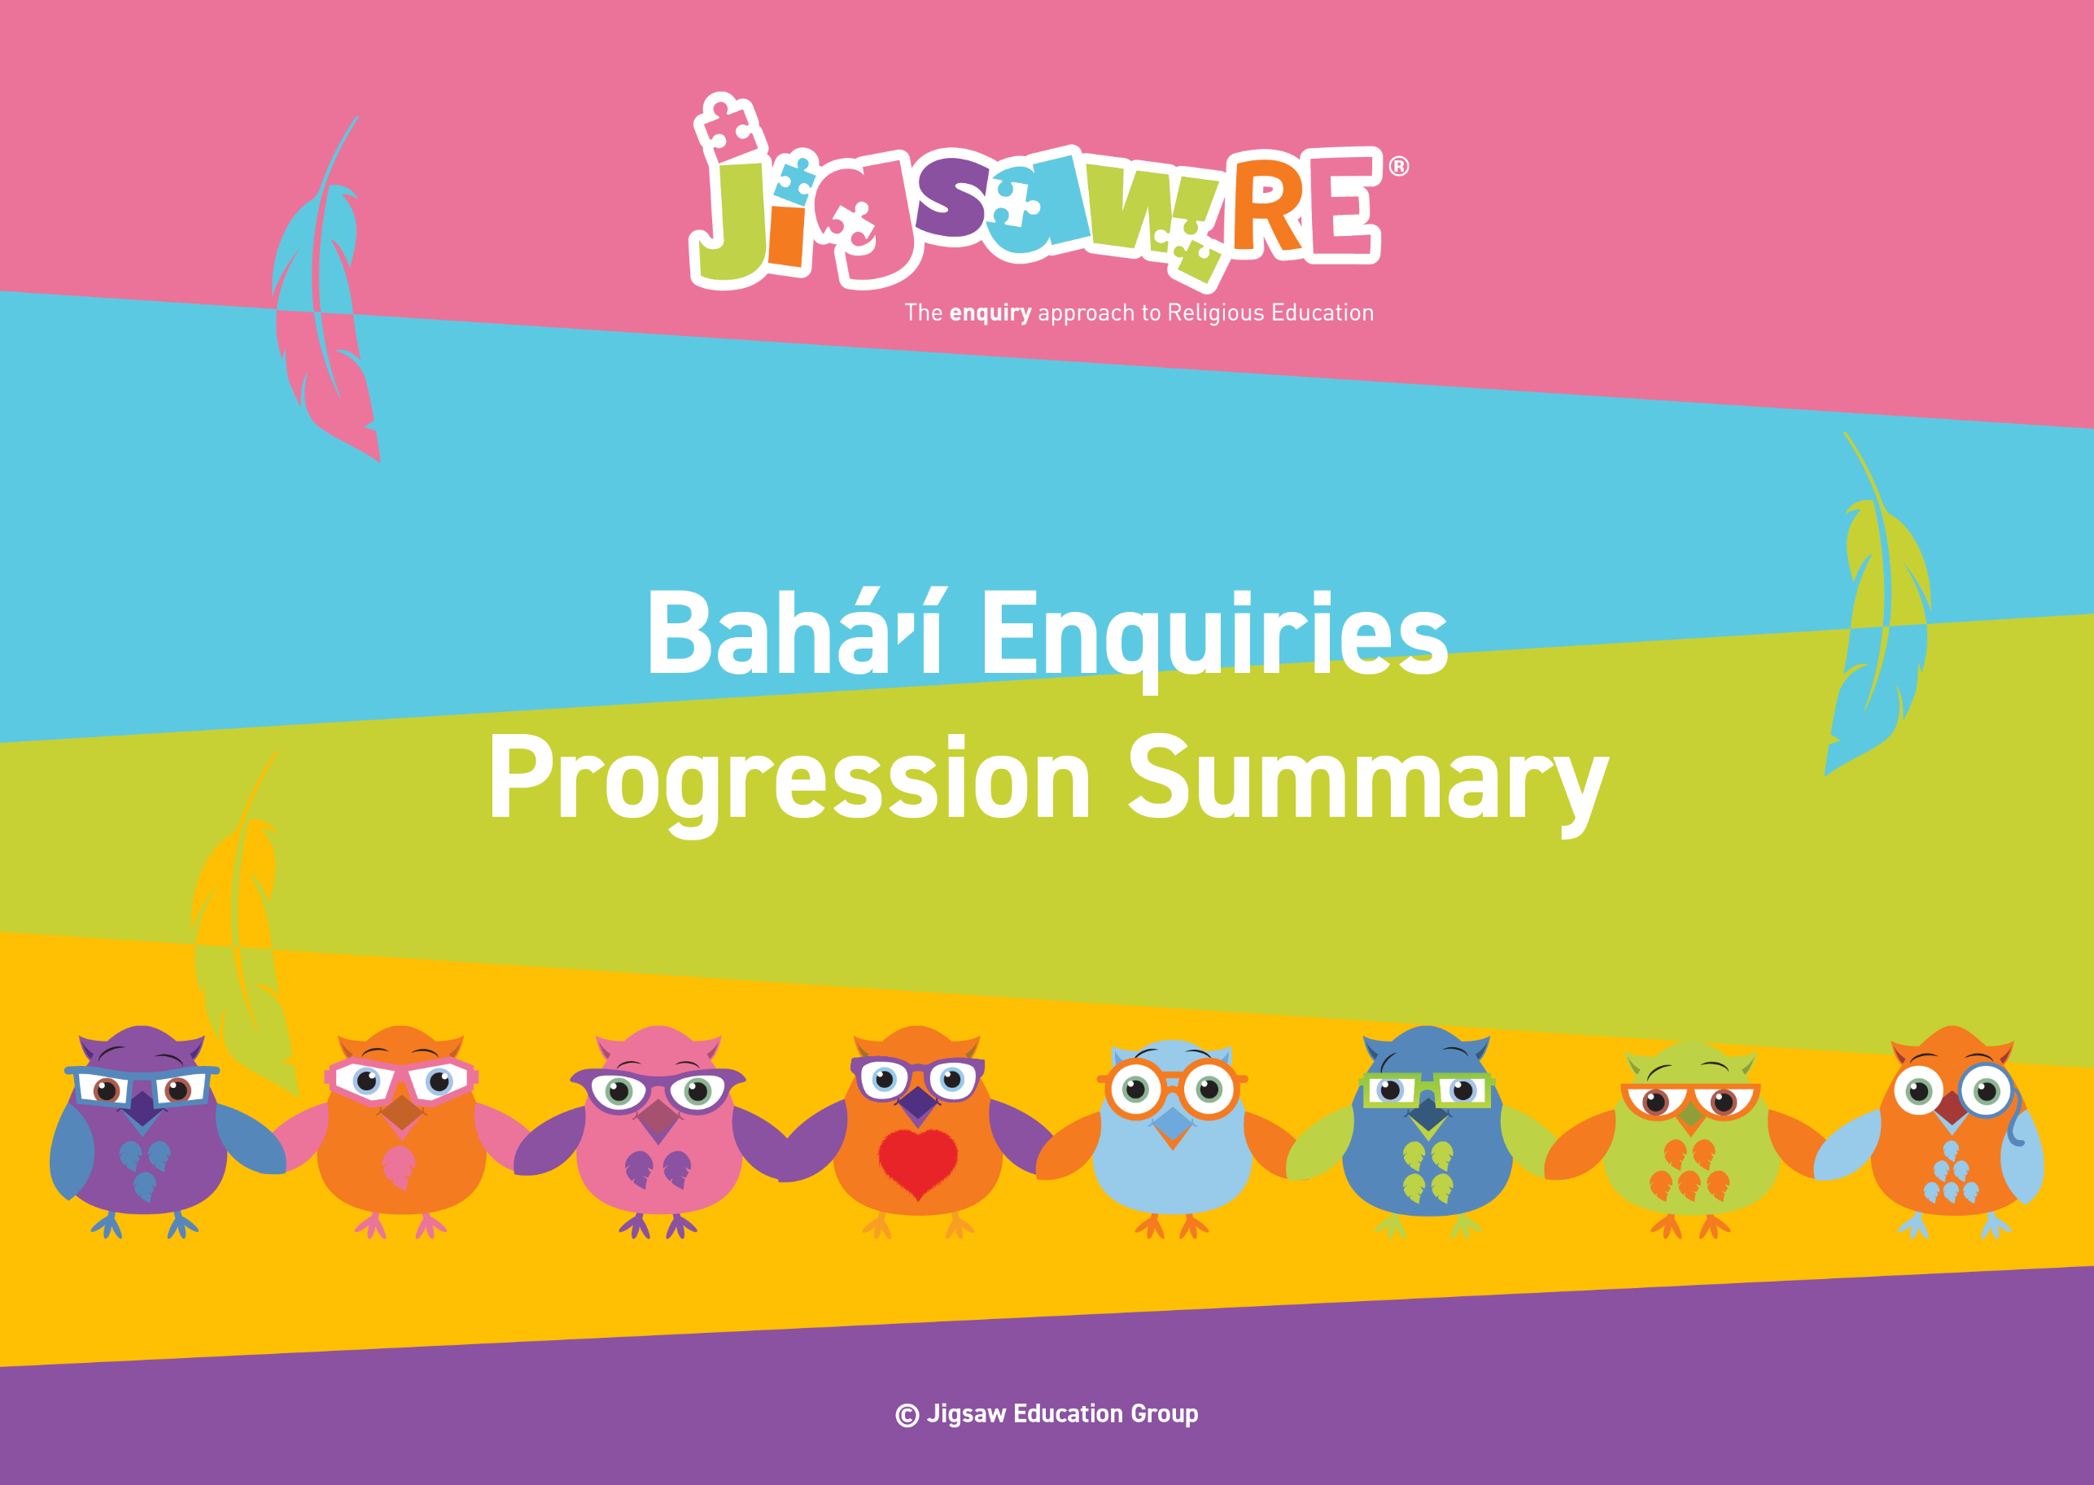







Baháʼí Enquiries Progression Summary

This document collects the relevant assessment statements and key vocabulary for the Worldview in one place.
Schools can use this collated information for their own curriculum documents, such as progression maps and knowledge organisers.
This can be used alongside the knowledge organisers for each enquiry.
Schools will need to select only from which of these enquiries they have chosen to teach.


The ‘I can’ statements represent a child working at expected levels for their age groups. ‘I am starting to’ statements indicate areas where children may be showing Working Beyond. These can also be found within each individual enquiry, alongside further statements for Working Below and Working Beyond (see assessment descriptors for more detail about exact judgements for each Enquiry).

The black statements are more generic progression of skills statements within the 3 areas of learning.
These will apply to whichever enquiries and Worldviews are chosen.

Enquiry | Green Descriptors:  Personal resonance with or reflection on the concept/belief underlying the subject matter of the enquiry. The child’s own thoughts, opinions, belief, empathy.  (personal development) | Blue Descriptors:  Knowledge and understanding of the subject matter of that enquiry (substantive/ subject knowledge) | Red Descriptors:  Skills of evaluation, research, critical thinking in relation to the enquiry question  (disciplinary knowledge) | Bridge Concept  &  Key Vocabulary
Years 1/2  Baháʼí  Generic Descriptors | I can tell you/talk about what concepts like special people/objects and respect mean to me in my world.  I can verbalise and/or express my own thoughts and feelings.  I am starting to see similarities/differences between my thoughts/feelings and other peoples’. | I am starting to use the religious vocabulary from the enquiry.  I can recall knowledge about the worldview I have studied.  I am starting to explain the significance and meaning of the learning, practices etc. | I can start to think through the enquiry question using some knowledge I have learned about the Worldview.  I am starting to see there could be more than one answer. | - Bahá’í  - Worldview  - Bahá’u’lláh
Years 1/2  Baháʼí  Enquiry 1  Who is God to Bahá’ís? | I can say what I could do to show people that I care (Enquiry 1)   | I can describe some of Bahá’í beliefs about God and what these might mean (Enquiry 1)  I am starting to explain how a Bahá’í's beliefs about God impact on their lives (Enquiry 1) | I can explain how Bahá’ís might show respect for these beliefs in their daily lives (Enquiry 1) |   Bridge Concept: Special people  - Special  - Responsible  - Leader  - Symbol  - Religion  - Prophet/messenger  - equal  - Earth

Enquiry | Green Descriptors:    Personal resonance with or reflection on the concept/belief underlying the subject matter of the enquiry. The child’s own thoughts, opinions, belief, empathy.  (personal development) | Area of Learning:  Knowledge and understanding of the subject matter of that enquiry (substantive/ subject knowledge) | Area of Learning:  Skills of evaluation, research, critical thinking in relation to the enquiry question  (disciplinary knowledge) | Bridge Concept  &  Key Vocabulary
Years 3/4  Baháʼí  Generic Descriptors | I can tell you/talk about the concept/belief (e.g. leading a good life) and start to relate this to the worldview I am studying.  I can express my own opinions and start to support them with rationales.  I can suggest similarities/differences between my thoughts/feelings and other peoples’. | I am using key religious vocabulary.  I can recall knowledge about the worldview I have studied.  I can select the knowledge that is most significant to the enquiry and start to explain its relevance and importance. | I can start to think through the enquiry question using some knowledge I have learned about the Worldview.  I am starting to see there could be more than one answer. | - Bahá’í  - Worldview  - Bahá’u’lláh
Years 3/4  Baháʼí  Enquiry 1  What is the best way for a Bahá’í to lead a good life? | I can explain different ways I could lead a good life (Enquiry 1)  I am starting to explain good choices I might make and why (Enquiry 1) | I can explain how a Baha’i might live a good life through living in moderation (Enquiry 1) | I can explain why I think moderation could help you live a good life (Enquiry 1)  I am starting to evaluate how moderation can impact whether you live a good life or not (Enquiry 1) | Bridge Concept: Leading a good life  - Similarities  - Differences  - Unity  - Equality  - Prejudice  - Values  - Virtues  - The Báb  - Devotional  - moderation  - gossip  - kindness
Enquiry | Green Descriptors:  Personal resonance with or reflection on the concept/belief underlying the subject matter of the enquiry. The child’s own thoughts, opinions, belief, empathy.  (personal development) | Area of Learning:  Knowledge and understanding of the subject matter of that enquiry (substantive/ subject knowledge) | Area of Learning:  Skills of evaluation, research, critical thinking in relation to the enquiry question  (disciplinary knowledge) | Bridge Concept  &  Key Vocabulary
Years 5/6  Baháʼí  Generic Descriptors | I can explain how this key concept/belief (e.g. commitment) resonates in my own life and can also see this might be different for other people because of their worldview.  I can express my own thoughts and feelings clearly, having reflected on them.  I can compare my own worldview to others’. | I am using key religious vocabulary from this enquiry and previous learning.  I can recall knowledge about worldviews and explain differences in practice and interpretation within and between worldviews. | I can weigh up evidence from different sources and consider different aspects in my answer to the enquiry question.  I can discuss the diversity of different beliefs and link it to the knowledge learnt in the enquiry.  I express my answer supported by evidence and/or a rationale. | - Bahá’í  - Worldview  - Bahá’u’lláh
Years 5/6  Baháʼí  Enquiry 1  What is the best way for a Bahá’í to show commitment to God? | I can explain what commitment means to me and how I show it (Enquiry 1)  I am starting to discuss the impact of showing commitment in my life (Enquiry 1) | I can explain some different ways in which a Bahá’í might show commitment to God (Enquiry 1) | I can say what I think is the best way for a Bahá’í to show commitment to God and explain my reasons (Enquiry 1)  I am starting to discuss the impact a Bahá’ís choices might make on their lives (Enquiry 1) | Bridge Concept: Commitment  - Commitment  - Dedication  - Resilience  - The Bab  - Devotions  - Obligatory  - Fasting  - worship  - environment

