
Distington Community School

Online Safety Newsletter: March 2019

Fortnite Battle Royale update

Fortnight is rated PEGI 12 for frequent mild violence. It is not suitable for persons under 12 years of age.

The PEGI rating considers the age suitability of a game, not the level of difficulty. Would you let your child watch a film classified as a 12? In the UK, it is an offence for someone to supply a game to someone under the age specified.

When rating games, PEGI do not take into consideration the chat features of a game which in this case could arguably be the greatest concern about letting your child play Fortnite. You may have seen in the news just recently of a case of a 41 year old man using the Fortnite voice chat to groom a child (Source: https://www.bbc.co.uk/news/technology-46923789). If you do choose to let your child play then consider the following:

- Chat functionality: Fortnite contains voice and text chat systems which can often contain inappropriate language. You can turn the voice chat off but not the text chat. To turn voice chat off, go to Settings, Audio and switch to off.

- In app purchases: All users can purchase V-Bucks directly through the game. This currency can be used to purchase items in the Fortnite store so make sure you don’t store your credit card details.

- Playing too much! The competitive nature of this game means it can be difficult for a child to stop playing, an average game lasts 20 minutes so set time limits on usage and remember to avoid any screen time one hour before bedtime.

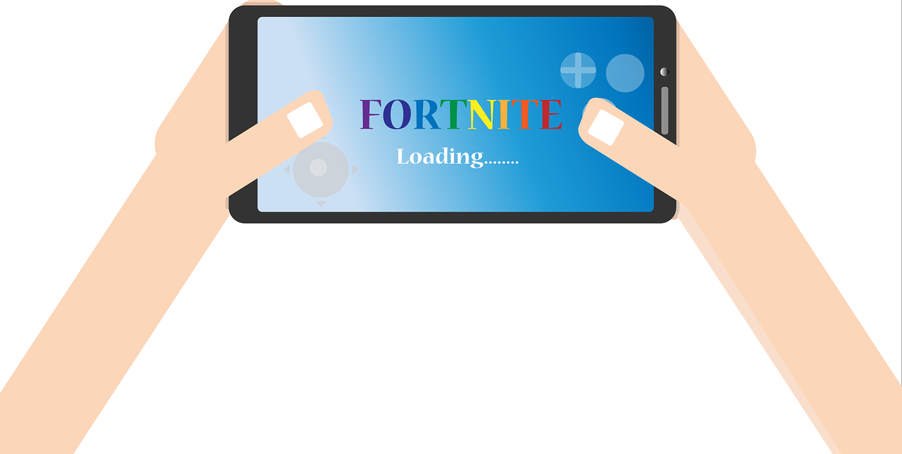
Play the game with your child, observe them whilst they are playing so you can monitor the sort of chat that they are listening to/contributing to via text chat. As always, show your child how to report any inappropriate behaviour and ensure that they know that they should talk to you or another trusted adult if they have any concerns.

On Fortnite you can report players by using the in-game feedback tool by selecting ‘Menu‘ and ‘Feedback’. Full instructions can be viewed here:
https://epicgames.helpshift.com/a/fortnite/?s=general&f=how-do-i-report-bad-player-behavior-in-battle-royale
Cyberbullying
Tik Tok (Musical.ly)

Music.ly was closed last year and users were automatically migrated to TikTok. TikTok state that users must be aged 13+. Users can watch musical clips, record 60 second clips, edit them and add special effects. Due to the nature of this app, videos may be inappropriate for some users due to their sexual nature or explicit language.

If you do choose to allow your child to set up an account then we recommend users have a private account to control who can see their videos and who can send them messages. Even with a private account, profile information (profile photo, username and bio) is seen by all users so ensure your child understands not to reveal any personal information in their profile e.g. don’t wear a school uniform in your picture. To set your child’s account to private:

- Go to your profile page, tap on the top right corner and select “Privacy and Settings”, Select “Privacy and Safety” option and toggle “Private Account” on/off

Tik Tok includes a ‘Restricted mode’ to limit the appearance of content that may be inappropriate. To set this:

- Select “Digital Wellbeing” under the app settings, tap “Turn On” and set a passcode, Toggle “Restricted Mode”

More information is available here:
http://support.tiktok.com/?ht_kb=for-parents


If it's unacceptable offline then it’s unacceptable online.

Think! It’s important to talk to your child about how they behave online, if they choose to use technology to call somebody names or spread hurtful rumours then they are involved in online bullying. Talk to your child, ask them how they would feel if the same was said or done to them?

What are your children saying online? It can be very easy online for children to behave in a way that they wouldn’t if they were face to face with each other. Talk to your children about how they are speaking to others online. Explain to them what to do if somebody is mean to them online, how should they respond (don’t respond, ignore them!), how to use reporting tools and to tell a trusted adult.

Childnet have just produced the following information pages in response to two key questions. The pages are full of advice and tips:

What makes a good online friend?
https://www.childnet.com/young-people/primary/get-answers/what-makes-a-good-online-friend

What should I do if someone online is mean to me?
https://www.childnet.com/young-people/primary/get-answers/what-should-i-do-if-someone-online-is-mean-to-me/

Further information
- https://www.childline.org.uk/info-advice/bullying-abuse-safety/types-bullying/online-bullying/
- https://www.childnet.com/parents-and-carers/hot-topics/cyberbullying
Digital books to read with your child

Vodafone and Parent Zone have produced two stories for you to read with your child to help them learn about online safety and to spark a conversation. Sally the Smartphone’s Digital Disaster (5 to 7 year olds) and Tommy the Tablet’s Birthday Blunder (7 to 9 year olds) are available here:
https://www.vodafone.com/content/digital-parenting/blogs/story-time-books-help-children-be-resilient-online.html

