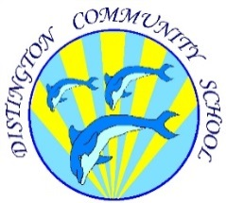
Distington Community School

Online Safety Newsletter: January 2019
Does your child know what personal information is?

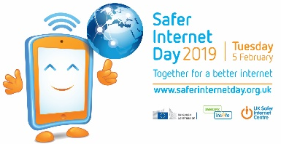
Does your child understand the importance of keeping information private? Are they aware that by uploading a video or photo online, they may actually be sharing private information without realising? For example, have they (or even you) ever uploaded a photo or video with the following in it:
Safer Internet Day next month

- Wearing their school uniform or wearing a local club shirt?
- Showing their local area in the background, perhaps inadvertently including street names, shop names or house numbers?
- Celebrating their birthday?

Talk to your children, do they realise the potential consequences of posting their personal information? Do they truly know all of their online ‘friends’? By sharing photos described above, a follower might be able to work out what school or clubs they attend, where they live and their date of birth. Do you want people knowing this information about your child?
Safer Internet Day 2019 will be celebrated globally on Tuesday 5th February 2019 with the theme: Together for a better internet.

To help you talk to your children about having a positive and safe time online, they have created a pack for you which includes conversation starters, a factsheet and family pledge card. Available here:

https://www.saferinternet.org.uk/safer-internet-day/safer-internet-day-2019/education-packs/education-pack-parents-and-carers

Online Chatting

What are your children saying online?


Most games now include some form of chat facility; this can be via a headset or via a messaging feature within the game. It is very easy within these chats to behave in a way that children wouldn’t if they were face to face with each other e.g. it is easier to call another child a nasty name via a screen than to say it to their face. These type of incidents can quickly escalate as online environments are often unsupervised so whereas an incident of name calling on the playground is quickly brought to the attention of a member of staff this doesn’t happen in an online environment.

Talk to your children about how they are speaking to their friends online. Sit with them while they are playing the game to see how your child chats with others, is it always appropriate? Explain to them what to do if they are called a nasty name, how should they respond and what they can do if a situation escalates.
Parents V Kids – are you ready?

Play the Parents vs Kids Alexa quiz from O2 & NSPCC. This is great for starting conversations about staying safe online. The whole family can play to see who knows the most about the online world. Play here:
https://www.o2.co.uk/help/nspcc/parents-vs-kids

Minecraft
(PEGI Rating 7 to 13 depending on version)
version)

Minecraft remains ever popular with it being played by 91 million people every month. Minecraft is a great learning tool and is often used in schools now to teach planning skills, recreate famous buildings in 3D and coding.

However, if your child is playing Minecraft, you need to be aware that in multiplayer mode they can chat with other people, most possibly strangers. For younger children we would recommend turning the chat facility off. To do this:
Go online to learn your timetables

Whilst there is an annual subscription charge of £6 (family plan) to access Timetables Rock Stars, this is a great game for reinforcing timetables by repetitively answering questions to the backdrop of a rockstar playlist to hopefully earn the title of Rock Hero! More information here:
https://ttrockstars.com/
- click ‘options’
- select multiplayer settings
- click on chat choose shown, hidden or commands only.

If you choose to keep the chat facility on then make sure your child knows what to do if anything upsetting happens.

In addition, protect your child’s privacy by using a nickname (don’t include their age/birth year) and also chat to your child to make sure that when playing online they know not to tell others personal information such as where they live, what school they go to and their age.

More information is available here: https://www.nspcc.org.uk/preventing-abuse/keeping-children-safe/online-safety/minecraft-a-parents-guide/
#Goldilocks: A fairytale for the digital age

Vodafone UK and Andersen Press have worked with author Jeanne Willis and illustrator Tony Ross to produce a co-branded digital edition of #Goldilocks. This book is a great way to start a conversation with your child about using social media responsibly.
https://www.vodafone.co.uk/mobile/digital-parenting/goldilocks



